**Project Title:**

**Course Work Two (2)**

Telecommunication Customer Churn Analysis

Business Analytics (7CS512)

Master of Science in Big Data Analytics (MI4AA)

School of Computing, College of Engineering and Technology

University of Derby.

Table of Contents

List of Tables 3

List of Figures 4

1 Introduction 5

1.1 Aims and Objectives 5

1.2 Description of the Tele Com dataset 5

2. Analytics Design 7

3. Data Analytics 9

3.1 Data Pre-processing 9

3.1.1 Data Cleaning 9

3.1.2 Data transformation 9

3.2 Data Mining 9

3.2.1 Descriptive Analysis: Frequency counts of telecom dataset 9

3.2.2 Diagnostic Analysis: What is the key churn determinant? 13

3.2.3 Predictive Analysis – Customer Churn Prediction 16

4. Critical Comparison of SAS and Python 20

4.1 Introduction 20

4.2 Overview of SAS and Python 20

4.3 Evaluation of SAS University edition and Python 20

5. Conclusion 22

5.1 Prescriptive Analysis 22

5.2 Conclusion 22

5.3 Future Work 22

1. References ......................................................................................................................................... 23
2. Peer Evaluation Form for Group Work ............................................................................................. 24
3. Appendix ........................................................................................................................................... 25

# List of Tables

Table 1: Description of Telecommunication Customers information variables........................ 5 Table 2: SAS University Edition and Python Evaluation Criteria Scoring ............................. 21

# List of Figures

Figure 1: Telecom churn data UML activity diagram. ............................................................... 8

Figure 2: Table showing missing values. ................................................................................... 9

Figure 3: SAS duplicates check log. .......................................................................................... 9

Figure 4: Telecom data frequency counts for gender and senior citizens. ............................... 10

Figure 5: Summary statistics for continuous variables (tenure, MonthlyCharges and

TotalCharges). .......................................................................................................................... 10

Figure 6: Histograms for MonthlyCharges, Tenure, and Totalcharges .................................... 10

Figure 7: Scatter plot of tenure and TotalCharges and Correlation ......................................... 11

Figure 8: Box plot of tenure by Gender. .................................................................................. 11

Figure 9: Bar Chart showing churn class count. ...................................................................... 12

Figure 10: Box plots of tenure, MonthlyCharges and TotalCharges by churn ........................ 12

Figure 11: Churn by gender chart and Churn by partner bar chart. ......................................... 13

Figure 12: Minimum and maximum points of churn groups. .................................................. 13

Figure 13: Random Forest model features importance and Fit statistics. ................................ 14

Figure 14: Telecom services subscriber’s count. ..................................................................... 15

Figure 15: Contract Income ..................................................................................................... 15

Figure 16: Customer Duration within Contracts ...................................................................... 16

Figure 17: Services Subscription by Contracts ........................................................................ 16

Figure 18: Pearson Correlation Coefficients ............................................................................ 17

Figure 19: Proc Logistic Step Code ......................................................................................... 18

Figure 20: Fit statistics of the Logistic Regression model. ...................................................... 18

Figure 21: Roc Curve for Logistic Regression Model ............................................................. 19 Figure 22: Customer Churn Prediction in Percentages ............................................................ 19

# 1 Introduction

Customer churn analysis and prediction in telecom sector is a critical issue that needs urgent attention because it’s very important for telecommunication industries to analyse behaviours of customer to predict which customers are about to leave service subscription from telecom company (Senthilnayaki *et al.,* 2021). Churn occurs in a company when customers discontinue using a company’s product or service during their contract and switch to a competitor for better, cheaper, or more satisfactory offerings (Sato *et al.,* 2010). As the backbone of any business, customers play a pivotal role in revenue generation (Roshin *et al.,* 2019). The telecom sector, where multiple providers compete, understanding and predicting customer churn are essential (Senthilnayaki *et al.,* 2021). Consequently, analysing customers churn behaviour, companies can develop effective strategies to increase customer retention (Jahromi *et al.,* 2012). As a result of this, this study focused on Prediction of Tele Com Customer Churn using SAS OnDemand software with a comparison with Python programming language.

## 1.1 Aims and Objectives

The aim of this study is to analyse the Telecom Customer dataset to gain valuable insights into the dataset, understand the cause of a customer churning to promote customer retention.

**The objectives of this study are.**

1. To analysis the Telecommunication Churn dataset sourced form Kaggle.
2. To identify key churn determinant in the telecommunication dataset.
3. To investigate the most relevant variables significance to telecom income
4. To implore predictive analysis to determine possibility of a customer churning for customers retention exercise.
5. To utilize analytics insights and make prescription to curtail customer churn.
6. To perform a critical comparison of SAS and Python analysis abilities relating to this study.

## 1.2 Description of the Tele Com dataset.

The dataset used for this study was Telecommunication Customer Churn sourced from Kaggle website (https://www.kaggle.com/datasets/blastchar/telco-customer-churn/data, n.d.). The entire dataset has 21 variables (columns) with 7043 observations (rows). The description of the key variables and characteristics of the dataset are shown in Table 1 below.

Table 1: Description of Telecommunication Customers information variables.

|  |  |
| --- | --- |
| **Column Name** | **Description** |
| Customer ID | Unique identifier assigned to each customer. |
| Gender | The gender of the customer, categorized as male, female |
| Senior Citizen | A binary indicator representing whether the customer is a senior citizen (1) or not (0). |
| Partner | Indicates whether the customer has a partner (e.g., spouse or significant other). |
| Dependents | Indicates whether the customer has dependents (e.g., children or elderly relatives). |
| Tenure | The length of time (in months) that the customer has been with the company. |
| Phone Service | Indicates whether the customer subscribes to phone service. |
| Multiple Lines | Indicates whether the customer has multiple lines. |
| Internet Service | Specifies the type of internet service subscribed to by the customer (e.g., DSL, fibre optic). |
| Online Security | Indicates whether the customer has online security features. |
| Online Backup | Indicates whether the customer has online backup services. |
| Device Protection | Indicates whether the customer has device protection services. |
| Tech Support | Indicates whether the customer has access to technical support services. |
| Streaming TV | Indicates whether the customer subscribes to streaming TV services. |
| Streaming Movies | Indicates whether the customer subscribes to streaming movie services. |
| Contract | Specifies the type of contract the customer has (e.g., month-to-month, one year, two years). |
| Paperless Billing | Indicates whether the customer has opted for paperless billing. |
| Payment Method | Specifies the method of payment chosen by the customer (e.g., electronic check, credit card). |
| Monthly Charges | The amount charged to the customer monthly for the services subscribed to. |
| Total Charges | The total amount charged to the customer over the entire tenure. |
| Churn | A binary indicator representing whether the customer has churned (1) or not (0). |

# 2. Analytics Design

Analytics design involves intentionally and systematically organizing the process of planning, executing, and evaluating data analysis activities. This entails establishing a structured approach for collecting, analysing, and assessing data to generate valuable insights. The utilization of UML diagrams facilitates this process by providing a standardized modelling language for visualizing and documenting software and system development, aiding in the specification and visualization of various system artifacts and business models. (Visual paradigm, 2024)

The activity diagrams visually represent the workflows and actions, incorporating features like data pre-processing, data mining, and data post-processing. They illustrate how control flows through the system, capturing complex business rules, operations, and use cases. Within the Unified Modelling Language framework, activity diagrams serve to represent both computational and organizational processes, encompassing workflows in various contexts. The telecom churn data UML activity diagram is shown below in the Figure 1.

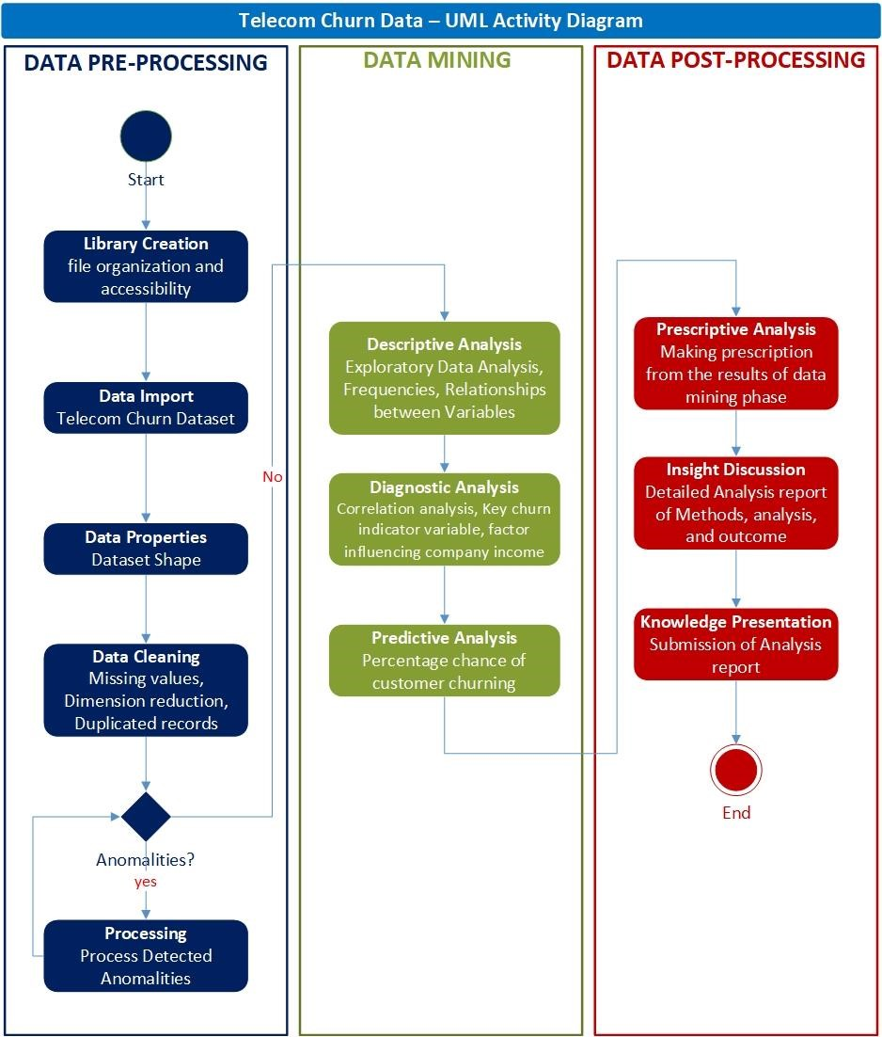

*Figure 1: Telecom churn data UML activity diagram.*

# 3. Data Analytics

Analysis in this section was carried out using SAS University edition and python. The code used to produce the results can be seen in the appendix section of this report.

## 3.1 Data Pre-processing

During this phase, a range of techniques were applied to the original dataset in readiness for the data mining activities.

### 3.1.1 Data Cleaning

The original telecom dataset underwent cleaning to ensure all fields in the dataset are filled and all customers are unique. These included checking for missing values, sorting the dataset, and checking for duplicates. It was discovered that there were 11 missing values in the TotalCharges variable which were consequently removed from the data, bringing the number of dataset observations from 7,043 to 7,032. The check for duplicates was applied specifically on the CustomerID variable, being the only variable expected to contain distinct values, and there are no duplicate entries found as shown in figure 3, being SAS log for duplicate check.

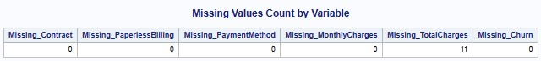

*Figure 2: Table showing missing values.*



*Figure 3: SAS duplicates check log.*

### 3.1.2 Data transformation

The format of the churn variable was recoded from character to numeric format for easy analysis related to correlation and prediction.

## 3.2 Data Mining

The dataset contains continuous and categorical variables. Categorical variables, whose insight regarding their frequencies and percentages are crucial to handling churning challenges at hand, and similar importance is the understanding of some descriptive statistics of the continuous variable.

### 3.2.1 Descriptive Analysis: Frequency counts of telecom dataset

Initial study of telecom dataset categorical variables revealed customers attributes, company services subscription/choices and churn class frequencies. As shown in figure 3 below, out of 7032 customers, 50.47% are male and 49.53% are female, 16.24% are senior citizens (aged 65 and above) and 83.76% are non-senior citizens. The explanation is similar for the rest of the categorical variables considered in this phase, which can be seen in the appendix section of this report.

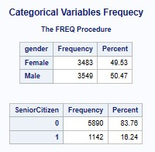

*Figure 4: Telecom data frequency counts for gender and senior citizens.*

#### 3.2.1.1 Distribution of Continuous variables

In furtherance to the study of the telecom dataset, we examine the distribution of the continuous variables as shown in figure 5 below.

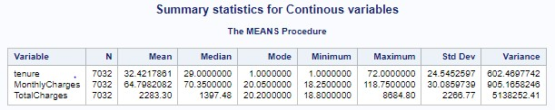

*Figure 5: Summary statistics for continuous variables (tenure, MonthlyCharges and TotalCharges).*

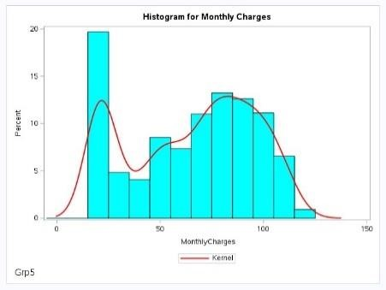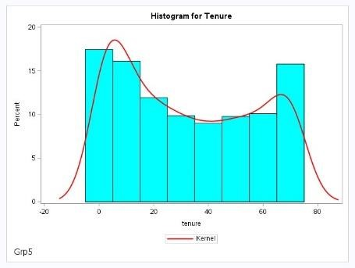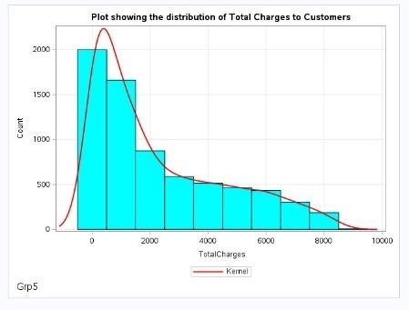

*Figure 6: Histograms for MonthlyCharges, Tenure, and Totalcharges*

The summary statistics in figure 5 and histograms in figure 6 above reveals that telecom data have more customers on 20.05 MonthlyCharges, 1 tenure, and 20.20 TotalCharges. Figure 5 shows that there are two main groups/clusters, hence two peaks: those far below average and those around the average MonthlyCharges as can be seen the variance column of figure 4. MonthlyCharges is therefore positively (right) skewed. For tenure, the distribution equally has two peaks, while most customers are below the average tenure, a good number are above the average, hence the negative (left) skewness of the distribution. For TotalCharges, the distribution is right skewed as customers are reducing as TotalCharges increases.

***What relationship does tenure have with TotalCharges?***

Since both variables are continuous, we first utilize the scatter plot to understand relationship which is explained with the figure below.

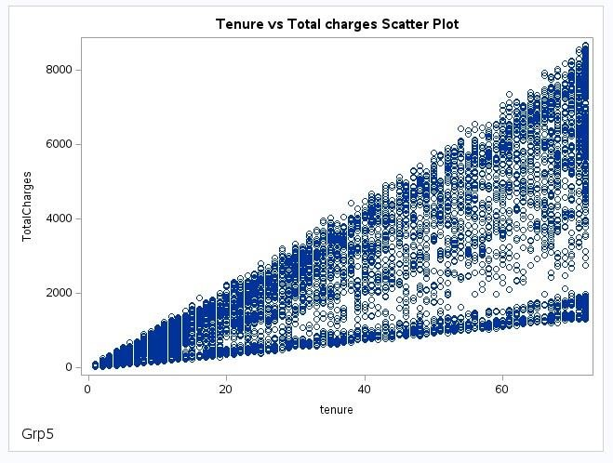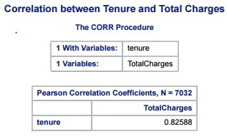

*Figure 7: Scatter plot of tenure and TotalCharges and Correlation*

The scatter plot shows that total Charges increases as tenure increases. This is verified with a correlation test, which results in a 0.82588 coefficient, confirming a strong positive relationship between tenure and TotalCharges.

**3.2.1.2 What customer gender group have longer tenure with the company?**

To answer this, we examine the box plot below.

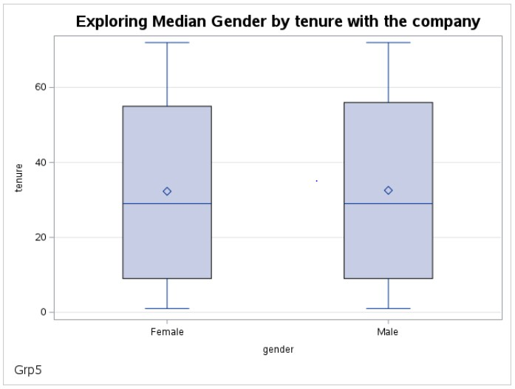

*Figure 8: Box plot of tenure by Gender.*

By observation, the median tenure for across gender appears very slightly different, if at all. To draw our conclusion, we employ the Mann-Whitney U Test to test at 0.05 significance level the null hypothesis, ***Ho: The median tenure across gender groups is the same.*** The P-value of

0.7699 is greater than our chosen level of significance, hence we fail to reject the null hypothesis. This means there is insufficient evidence to conclude that there are significant differences between the medians of the two gender groups.

**3.2.1.3 Telecom customers churn investigation.**

We want to understand churn by looking at telecom dataset in general.

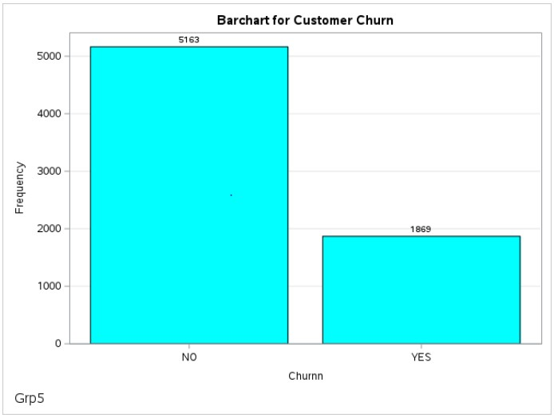

*Figure 9: Bar Chart showing churn class count.*

From figure 9 above, a total of 1869 representing 26.58 percent of the customers that churned.

Next, we examine how these churn classes are distributed over tenure, MothlyCharges and TotalCharges which is depicted in figure 10 below.

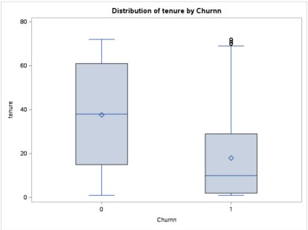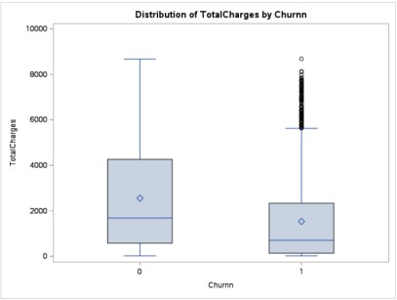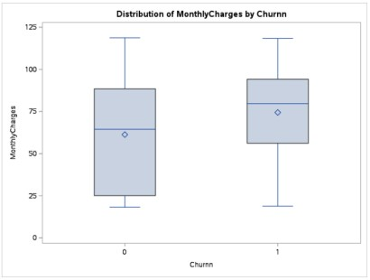

*Figure 10: Box plots of tenure, MonthlyCharges and TotalCharges by churn*

The above figure, 0 = No to churn and 1 = Yes to churn. It reveals that the average tenure for customers that churned is around 20, with median tenure below 20. However, there were unexpected few cases where customers stayed above 70 tenures and still churned. For emphases, customers are more likely to churn during under 20 tenures. Average MonthlyCharges for customers that churned is around 73 with median around 75. Median TotalCharges for churned customers is below 800 and average around 1700, having some customers whose TotalCharges is above 6000 but unexpectedly churned.

***How does customer Churn compare across gender and Partner groups?***

We us the bar chart in figure 11 below to answer this question.

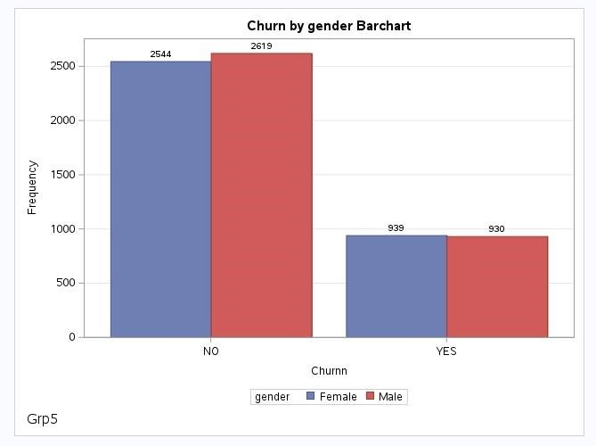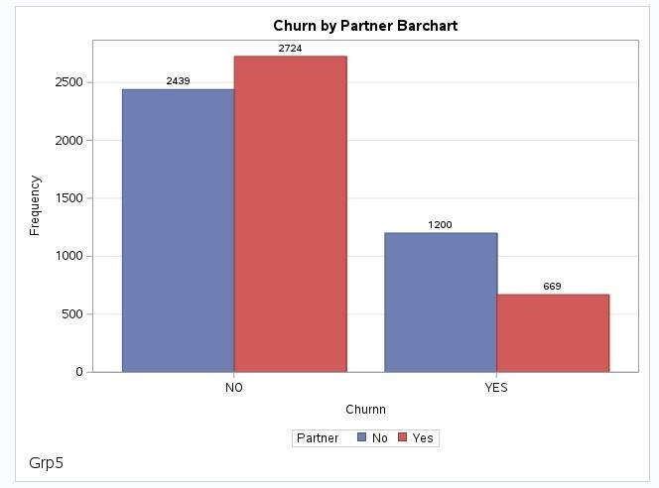

*Figure 11: Churn by gender chart and Churn by partner bar chart.*

The above bar chart shows that churn is higher among female customers, despite having more male customers. On the other end, churn is higher among customers without partners, even though there are more customers that have partner.

***Do customers churn at a particular tenure?***

We worried about a possibility that customers tend to churn at a particular tenure period. We therefore must know the minim and maximum tenure across churn groups.

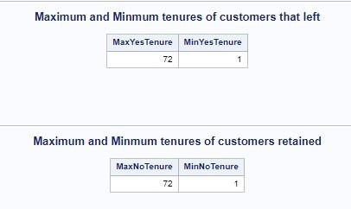

*Figure 12: Minimum and maximum points of churn groups.*

We rule out all assumption that customers might be churning once they get to a certain tenure, as can be seen in figure 11 that both customers that churned and the ones that didn’t that have spent same maximum and minimum tenure.

### 3.2.2 Diagnostic Analysis: What is the key churn determinant?

Having explored churn in relation to all continuous variable and owing to the range of categorical variables available to us, we employ a predictive algorithm, particularly the random forest to ascertain the most important variable. A random forest is an ensemble learning method that combines multiple decision trees. Each tree is trained on a different subset of the data. The final prediction is based on the majority vote (classification) or average (regression) of individual tree prediction (Eden Molina, 2021).

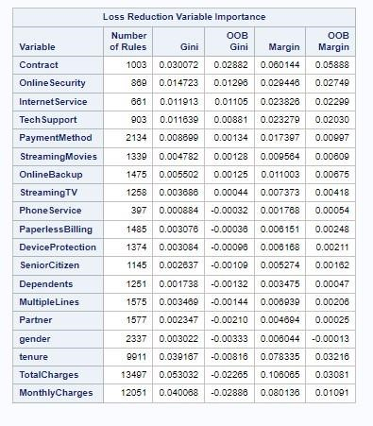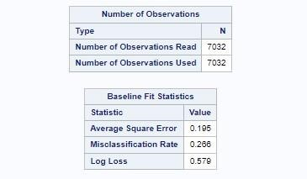

*Figure 13: Random Forest model features importance and Fit statistics.*

The random forest model implemented as shown in figure 13, have classification accuracy of 73.4% (1 - misclassification rate)*100, recognising Contract with the highest OOB Gini score as the most important variables in predicting churn. The OOB (out-of-bag) Gini, also known as the mean decrease impurity (MDI) measures the decrease in accuracy on OOB data when the values are randomly permuted for that feature. If the decrease is low, then the feature is not important, and vice-versa (Breiman et al, 1984).

We therefore proceed to properly evaluate Contract variable relevance to telecom dataset regarding income and particularly customers’ churn.

***How relevant is Contract to Company’s Income?***

To understand contract, a broad overview of all services available for contract subscription and number of customers subscribed to each service. The output is displayed in figure 14below.

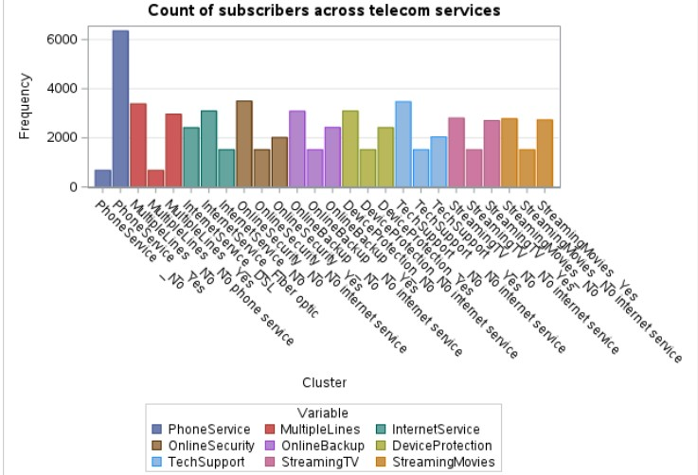

*Figure 14: Telecom services subscriber’s cluster.*

This graph shows that apart from phone service which larger percentage of the company's subscribers are paying for, internet services, streaming services are largely being utilized by the customers. From the earlier section, it was determined that “Contract” is the most significant factor for customer churning. Considering this, we looked at the income being generated by the different contract package and why the income is so.

#### 3.2.2.1 Contract Income

A table was designed to calculate the total income from each contract as displayed in figure 15 below. In addition to the sum, the mean was also included. This is important because there is different count in the contract, which will impact the total, the best way to understand which contract has brought in most income to the company, the mean is very crucial.

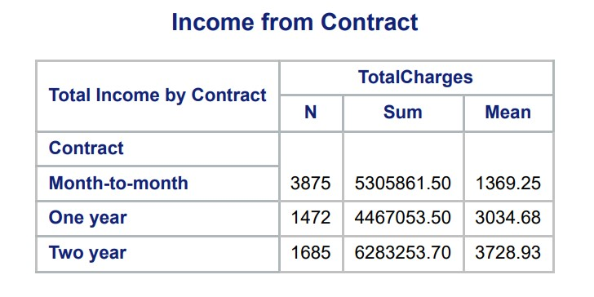

*Figure 15: Contract Income*

From the output, a very important insight was determined, even though the month-to-month contract has almost double the customers as the one year or two years contract, it made the least income for the company. This led us to the Why aspect of this section, why are the other contracts, in particular two years contract making more income for the company?

Firstly, we examined the contracts with how long they have stayed with the company, as shown in figure 16 below, it shows that month-to-month customers tend to churn earlier than the remaining contract types. And the longer a customer stayed with the company, the more income is being generated because the customer pays monthly for a longer period.

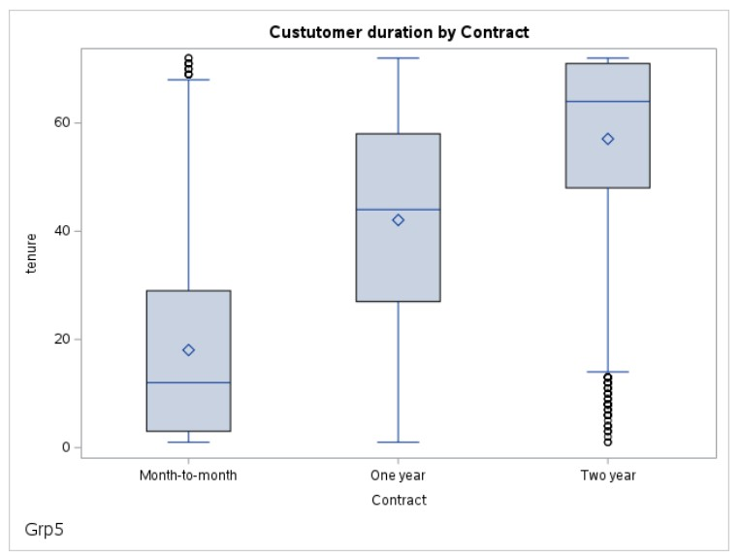

*Figure 16: Customer Duration within Contracts*

Adding to this, using the tabulate procedure, we investigated the services that customers in each contract are subscribed to. The table is in percentage to get a more quantifiable concept from each contract. The generated table is displayed below:

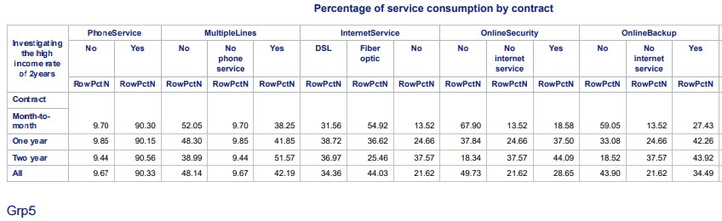

*Figure 17: Services Subscription by Contracts*

The table shows that month to month subscribers do not generally subscribe to other services such as online security, online back, etc. This in addition to early churn rate is probably the contributing factor to monthly subscribers generating least income for the company, and two years and yearly contract recording higher income.

### 3.2.3 Predictive Analysis – Customer Churn Prediction

In this section, we are building a model to learn patterns in the dataset to try to understand the customer behaviours and to predict by calculating the percentage chance of a customer churn in the company. The advantages of this to the stakeholders and the company is immense, the customers with high percentage of churning but are still with the company can be targeted early on to prevent them from leaving the company. This process is split into the following sections:

* Creating a machine learning model using logistic regression algorithm.
* Evaluating the model.
* Calculating the percentage chance of each customer leaving.

#### 3.2.3.1 Correlation Matrix

To begin the process, we first encoded the entire dataset into a numeric value. Although this step may not be necessary for the proc logistic as it performs encoding by itself, it is necessary for the implementation of the **PROC CORR** step. This procedural step in SAS is used to compute the correlation between variables in SAS, and it only works on numeric variables. The conversion of categorical variables to numeric does not really work as correlation works under assumption of linearity, in this case, the aim of this step is to check for redundancies or dependencies in the sense that if one variable can be gotten from another variable and any linear relationships within the variables in the data. The result of the proc Corr step is displayed below:

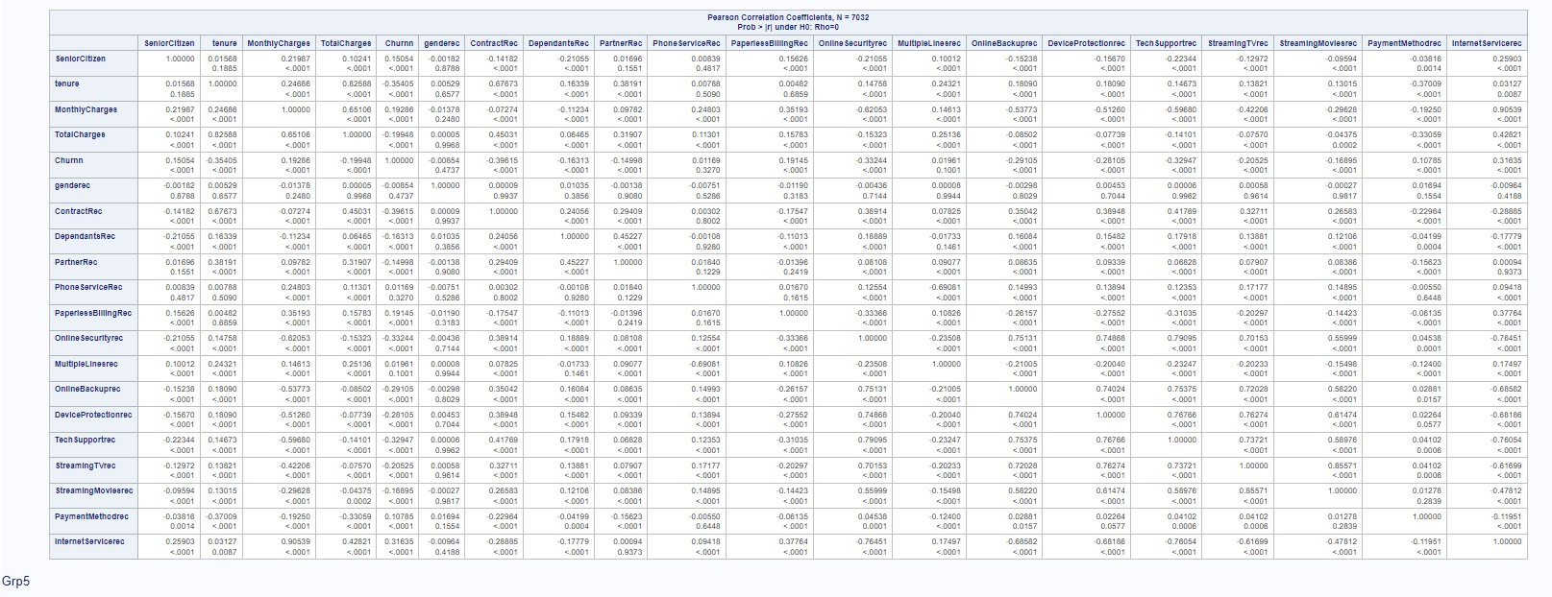

*Figure 18: Pearson Correlation Coefficients*

The correlation matrix showed high correlation between variables tenure and totalcharge, also between internet service and monthlycharge. In this instance we will not be removing either of the variables because it is not a perfect correlation and tenure or totalcharge may carry hidden information about the customer behaviour, also both internet service and monthly charge will be used, one of them is categorical and the other is continuous. The target variable “Churnn” itself have no correlation with any of the features.

**3.2.3.2 Logistic Regression Machine Learning Model.**

Due to the nature of the target variable, which is a binary variable, a classification algorithm is ideally suited for this objective. Thus, logistic regression was adopted. SAS offers a procedure step which performs the logistic regression brilliantly. As shown in figure 19below, the PROC LOGISTIC step was initiated and in it, all the features were specified, first identifying the categorical variables using the “class” option, after, the interested binary value “1”, which signifies churn was specified for the model. In addition, the LogOdds of getting a 1 (Churn) was calculated and stored in another column, this is then used for the percentage calculation.

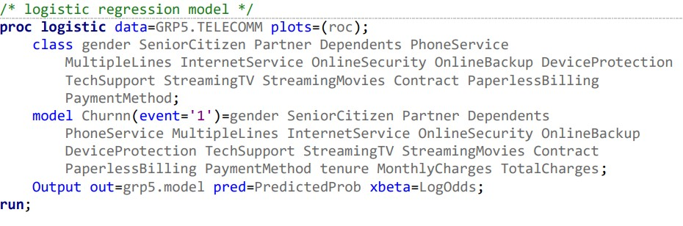

*Figure 19: Proc Logistic Step Code*

**3.2.3.3 Model Evaluation** looking at the fit statistic of the model, the AIC (Akaike Information Criterion), SC (Schwarz Criterion) and –2LogL (Negative twice the log-likelihood) of intercept and covariates is lower than the intercept only. This reinforces that churn rate is not the same for all customer, the lower values gotten from intercept and covariates suggests that different features like tenure, or services subscribed can impact the churn rate of a customer, which ultimately led to better model being developed.

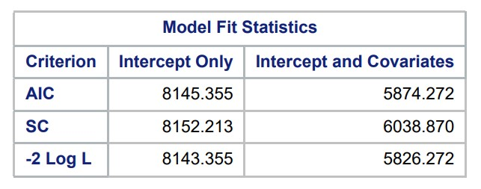

*Figure 20: Fit statistics of the Logistic Regression model.*

Specified within the code as shown in figure 20above, a roc curve was plotted to visualize the performance of the model. Shown in figure 21 below**,** the area under curve of 0.8482. this indicates a good discriminative ability between the positive and negative classes in the target. In every instance of randomly selected customer, the model ranks the customer the customer correctly about 84% of the time.

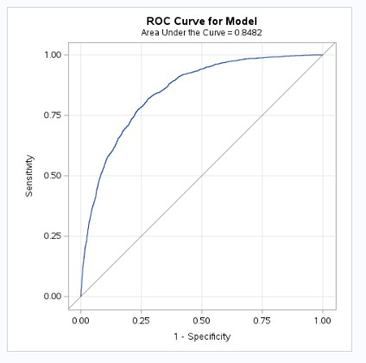

*Figure 21: Roc Curve for Logistic Regression Model*

#### 3.2.3.4 Churn Percentage Prediction

Following evaluation of the model, the percentage of each customer churn was calculated to enable early intervention for high-risk customers. Figure 22 below shows the output of this stage, and some of the higher percentages already churn and those that haven't should be immediately targeted to facilitate customer retention with the firm.

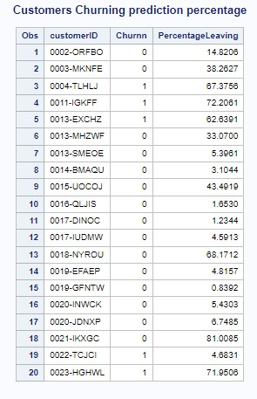

*Figure 22: Customer Churn Prediction in Percentages*

# 4. Critical Comparison of SAS and Python

## 4.1 Introduction

During this study, we used two tools to carry out the analysis on the telecom dataset. The first is the SAS university edition and the second is Python. In this section, we will be comparing both tools which will cover a range of criteria which includes ease of use, tool’s efficiency, data handling, visualization, cost etc.

## 4.2 Overview of SAS and Python

SAS (Statistical Analysis System) is a software suite created by the SAS Institute capable of mining, modifying, managing, and extracting data from diverse sources, as well as conducting statistical analyses. Its programs are composed of DATA steps and PROC (procedures). The DATA steps are responsible for retrieval and manipulation while PROCs are used for data analysis. These programs may also include functions. Each step in SAS program is made up of sequence of statements. (geeksforgeeks, 2022)

Python is a high-level, object-oriented programming language known for its simplicity and readability. It finds extensive use in diverse domains like web development, data analysis, scientific computing, automation, and artificial intelligence. (W3schools, 2024) Python was created by Guido van Rossum in 1991. Its subsequent development has been carried out by the Python Software Foundation. (geeksforgeeks, 2023)

## 4.3 Evaluation of SAS University edition and Python

A critical evaluation between SAS and Python is conducted and presented, the evaluation carried out under these major headings, Installation and setup, Usage, Data Pre-processing, Data Analytics and Output.

**Installation and Setup**

The installation of SAS has more steps to it, from signing up on SAS website and launching the environment, it then gets more complex with library creation and configuration to hold data and variables. While for Python, it is relatively easier, after installing Jupyter Notebook (also installs Python by default), it only requires launching jupyter notebook by double clicking, and create new python file.

**Usage**

Python is a programming language, and jupyter notebook is an integrated development environment (**IDE),** this means that, user friendliness is not a major concern during development. It is strictly coding environment and requires coding experience while SAS is offers advance options such as going interactive, various tasks and utilities option to help with the coding experience.

**Data Pre-Processing**

Both SAS and Python offers good options for pre-processing, python has large library which further extends the capabilities of python. Even though its only coding, its relatively straight forward to perform these steps after installing required library. While in SAS, Data combination, cleaning and manipulation is more complex which includes various integration of DATA and PROC steps.

**Data Analytics**

In SAS there are number of built-in statistical and analytical functions while these functionalities can be extended into python with libraries such as NumPy, Pandas etc. SAS has some many Auto Functions such like checking for distributions, correlation and cluster analysis. For Python, all these tasks can be achieved using lines of codes which can be more daunting.

**Output**

Python enables different form of libraries such as Seaborn, Matplotlib etc. for visuals, and dynamic visualisations which are superior to those available in SAS.

To quantify our observation using both tools, a score will be assigned to both tools out of 5. The score is collectively debated and agreed upon by all the team members involved in this analysis. This gives a more comprehensive evaluation of both analytical tools. Table 2: SAS University Edition and Python Evaluation Criteria Scoring

|  |  |  |
| --- | --- | --- |
| **Criteria** | **SAS Score** | **Python Score** |
| **Installation and Setup** | |  |
| Ease of Installing | 5 | 3 |
| Platform Dependency | 4 | 1 |
| **Usage** | |  |
| Ease of Use | 4 | 2 |
| User-friendliness | 3 | 2 |
| Flexibility | 2 | 4 |
| Efficiency | 3 | 5 |
| **Data Pre-processing** | |  |
| Data Importation | 3 | 5 |
| Data Cleaning | 5 | 3 |
| Data Transformation / Manipulation | 3 | 4 |
| Data Filtering | 4 | 4 |
| **Data Analytics** | |  |
| Descriptive Analytics | 4 | 3 |
| Diagnostic Analytics | 4 | 2 |
| Predictive Analytics | 3 | 5 |
| **Output** | |  |
| Data Visualization | 3 | 5 |
| Tabulation | 5 | 3 |

# 5. Conclusion

## 5.1 Prescriptive Analysis

Following our descriptive, diagnostic, and predictive analytics, the following prescription is considered helpful for reducing customer churn. This prescription will not be valid for inevitable situations like customer demise.

1. Swift intervention with personalized offers, discounts, or dedicated customer support can help retain these customers. Our logistic regression model with simplified customer churning percentages helps with predicting customer churn possibility. Customers with above 50% churning percentages should be mostly targeted for the said interventions.
2. End-of-Contract Offers: We have noticed that customers in long (one year or two year) contracts also churn. As these types of customer contracts near expiration, present enticing end-of-contract deals, such as discounted rates, upgraded service plans, or exclusive perks. Transparent communication of these offers well ahead of the contract expiration date can strengthen customer loyalty.
3. Encourage Lock-In: Most churn cases happened with customers on month-to-month contract. Introducing incentives like payback schemes and data rollover can compel customers to stay by tethering them to accrued rewards they’d lose upon departure.
4. Cultivate Loyalty & Rewards: Our analysis has established that income depends on tenure which is mostly determined by customer contract type. Programs like Implementing loyalty programs that offer discounts, upgrades, or exclusive rewards for long-standing customers. This can incentivize sustained engagement and deter churn, thereby improving income generation.
5. Build Personalized Plans: We have noticed that there are differences in churn across classes of Gender, Senior Citizen, Partner groups. Creating personalized plans for different customer profiles will help reduce churn in different groups.
6. Upgrade Existing Accounts: From services subscription analysis, different services should be considered being added for customers without additional pay to give customers opportunity to experience higher contract values. Making these upgrades on existing accounts will help retain and affect decision to upgrading to higher contract.

## 5.2 Conclusion

This analysis has reinforced the need for customer churn analysis in telecommunication sector leveraging on SAS OnDemand and Python programming for predictive analytics. From this analysis we identified key factors influencing churn, in which contract emerged as the most significant predictor of churn. This study further compared the analytical tools SAS and Python highlighting their strengths, while SAS is particularly useful in data cleaning and preprocessing, python offers superior flexibility and visualization capabilities. Our predictive model, which was based off logistic regression provided actionable insights, enabling earlier targeted interventions to aid customer retention.

## 5.3 Future Work

Future works can build on this analysis by utilizing advanced machine learning techniques such as deep learning to enhance the predictive accuracy of the churn model. In addition to this, a larger dataset which include more diverse demographic and behavioural variables could provide new insights. Furthermore, a study to track the impact of the prescribed strategies over time could offer valuable feedback and guide in continuous effort in churn prevention (Customer Retention).

**References**

1. Breiman, L., Friedman, J.H., Olshen, R.A., and Stone, C.J. (1984) Classification and Regression Trees. 1st ed. New York: Chapman & Hall/CRC.
2. Eden Molina (2021) A Practical Guide to Implementing a Random Forest Classifier in

Python [Online]. Towards Data Science. Available from:

<https://towardsdatascience.com/a-practical-guide-to-implementing-a-random-forestclassifier-in-python-979988d8a263> [Accessed 2 April 2024].

1. geeksforgeeks, 2022. Introduction to SAS programming. [Online] Available at: <https://www.geeksforgeeks.org/introduction-to-sas-programming/>[Accessed 20 May 2024].
2. geeksforgeeks, 2023. Introduction To Python. [Online] Available at: <https://www.geeksforgeeks.org/introduction-to-python/?ref=lbp>[Accessed 20 May 2024].
3. Roshin Reji, Rohit Zacharias, Sebin Antony and Merlin Mary James (2019) “Churn

Prediction in Telecom sector using Machine Learning”, International Journal of Information Systems and Computer Sciences, Vol. 8, No.2, pp. 832–937.

1. Sato T, Huang B.Q, Huang Y, Kechadi M.T and Buckley B (2010) “Using PCA to Predict Customer Churn in Telecommunication Dataset”, International conference on Advanced data mining and applications, Vol. 2,pp. 26-27..
2. Senthilnayaki B 1, Swetha M 2, Nivedha D 3 (2021) CUSTOMER CHURN PREDICTION. International Advanced Research Journal in Science, Engineering and Technology Vol. 8, Issue 6, June 2021 DOI: 10.17148/IARJSET.2021.8692 Copyright to IARJSET IARJSET 527. DOI: 10.17148/IARJSET.8692
3. T. Jahromi, M. Moeini, I. Akbari, and A. Akbarzadeh (2013) ‘‘A dual-step multialgorithm approach for churn prediction in pre-paid telecommunications service providers,’’ J. Innov. Sustainab., vol. 1, no. 2, pp. 2179–3565
4. Telecom Churn dataset, 2024. [Online] Available at: https://www.kaggle.com/datasets/blastchar/telco-customer-churn/data, n.d. In: s.l.:s.n.[Accessed 10 April 2024].
5. Visual paradigm, 2024. What is Unified Modeling Language (UML)?. [Online] Available at: [https://www.visual-paradigm.com/guide/uml-unified-modelinglanguage/what-is-uml/](https://www.visual-paradigm.com/guide/uml-unified-modeling-language/what-is-uml/) [Accessed 10 May 2024].
6. W3schools, 2024. Python Overview. [Online] Available at: <https://www.w3schools.in/python/overview/#google_vignette>[Accessed 20 May 2024].

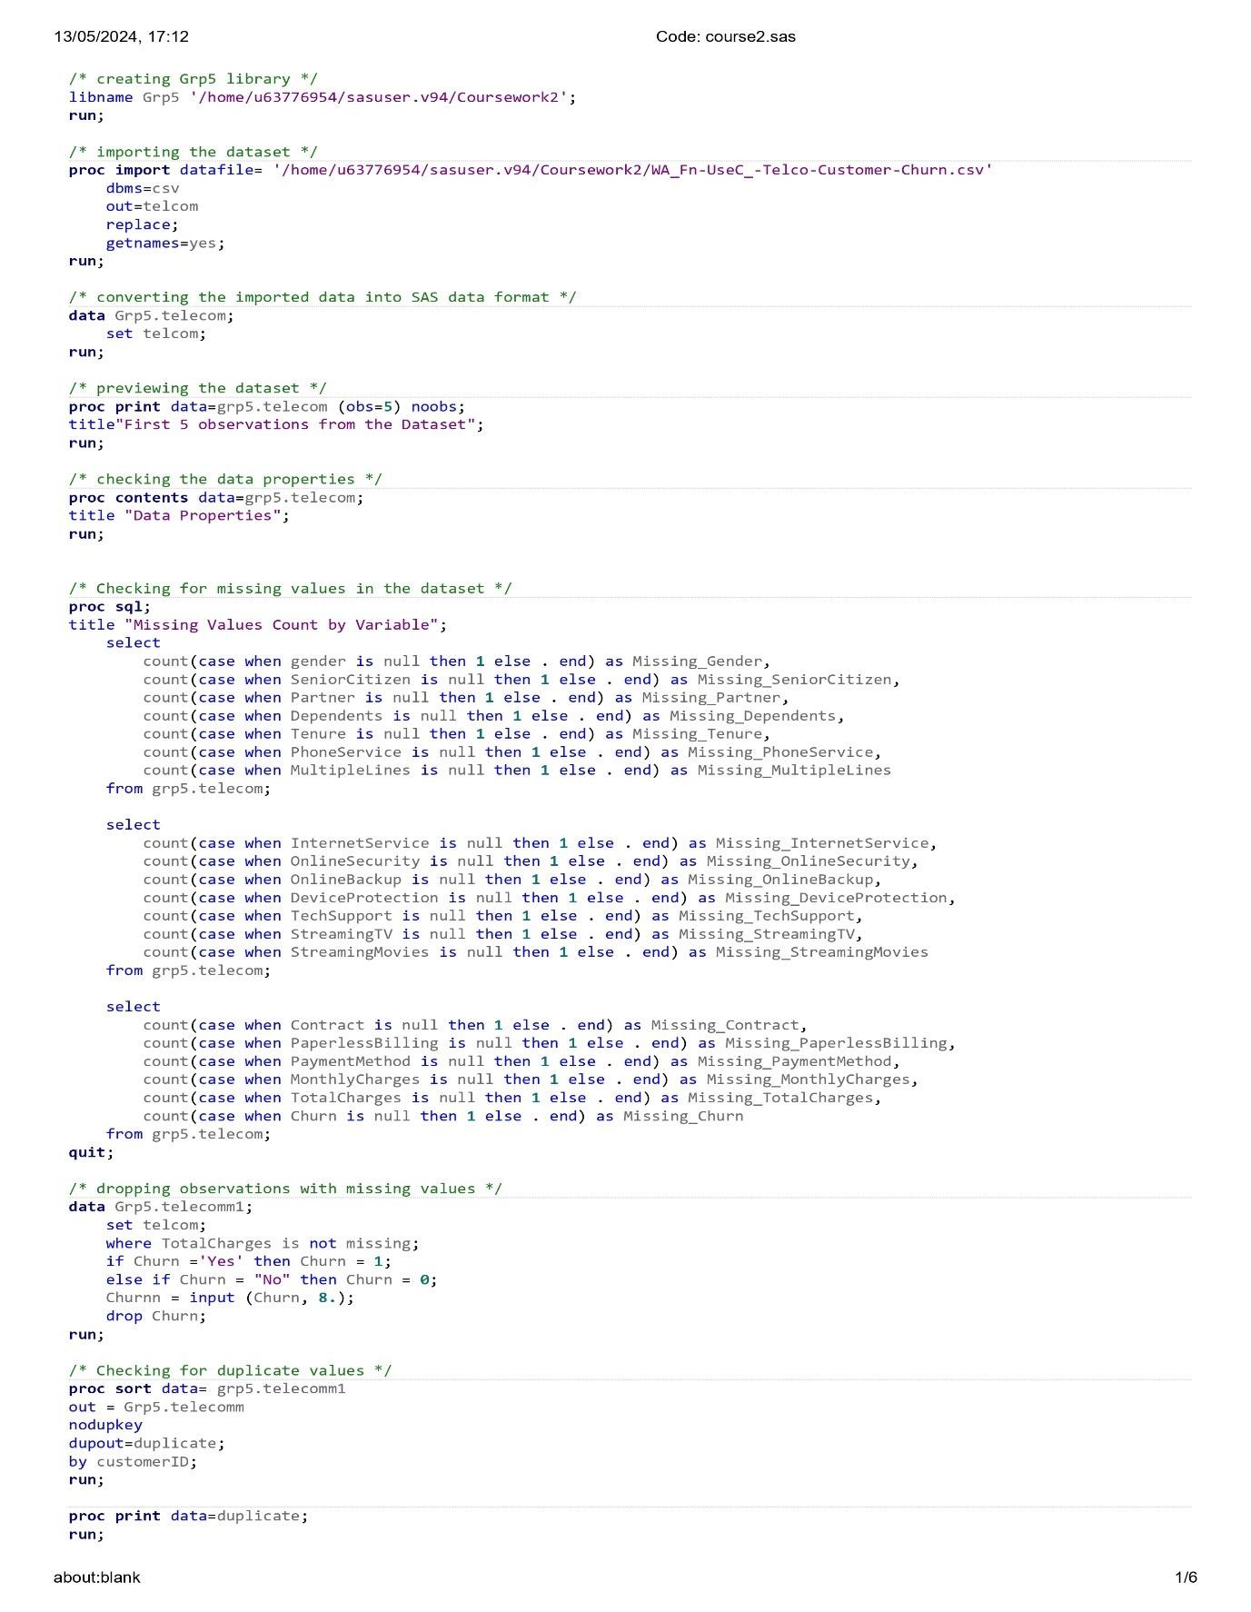

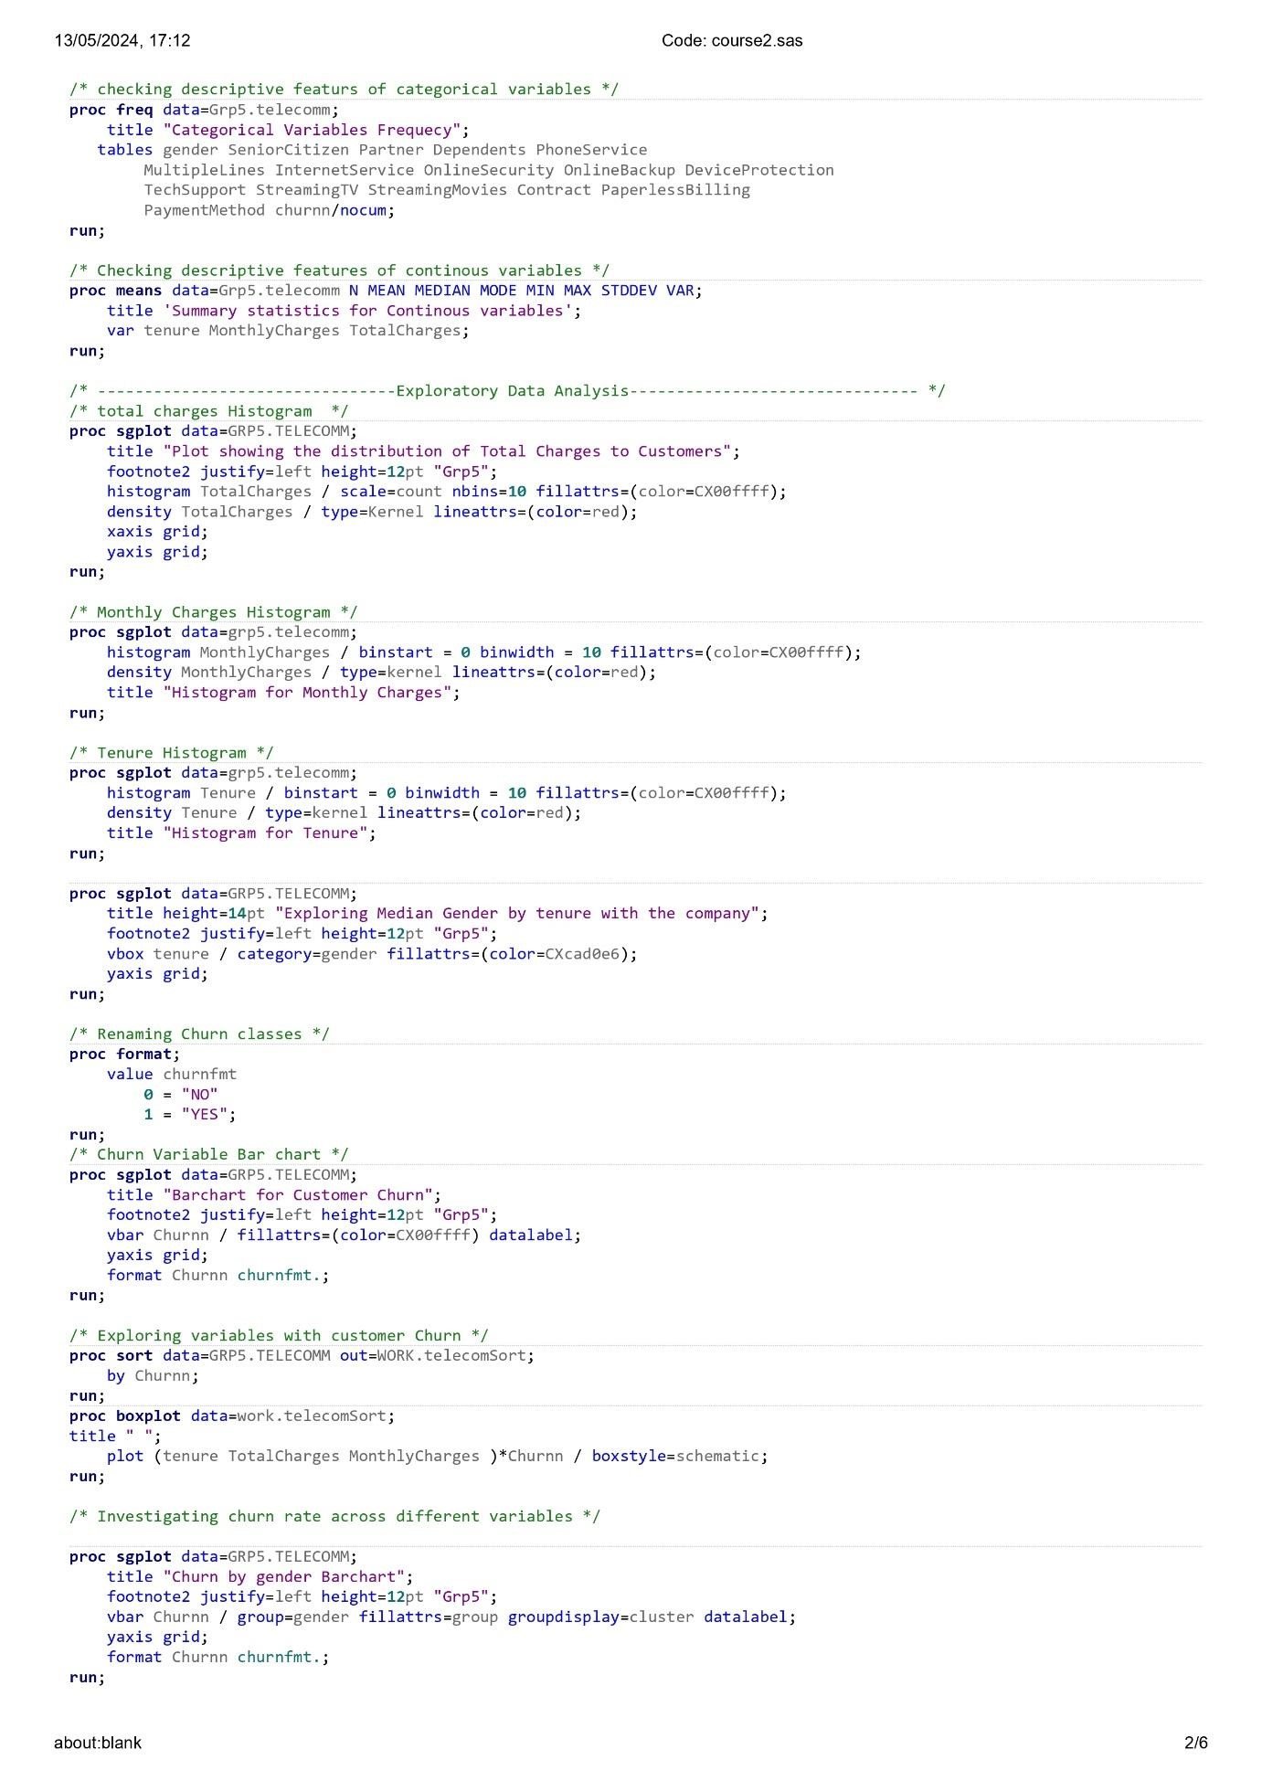

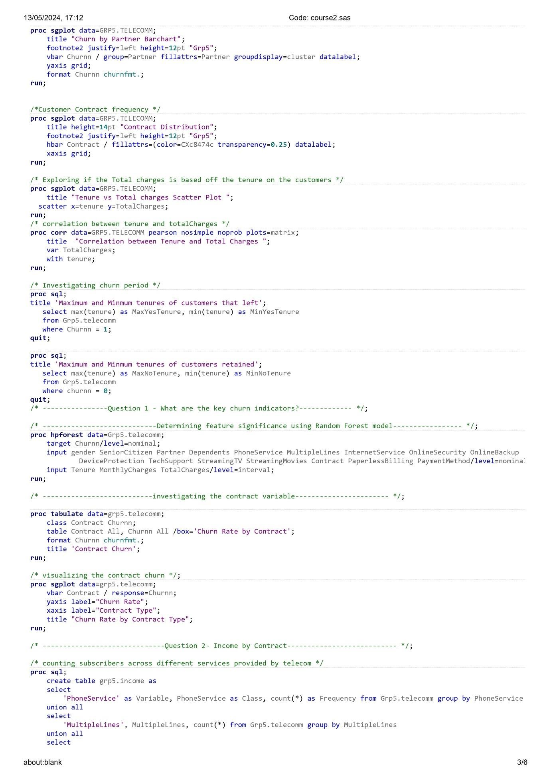

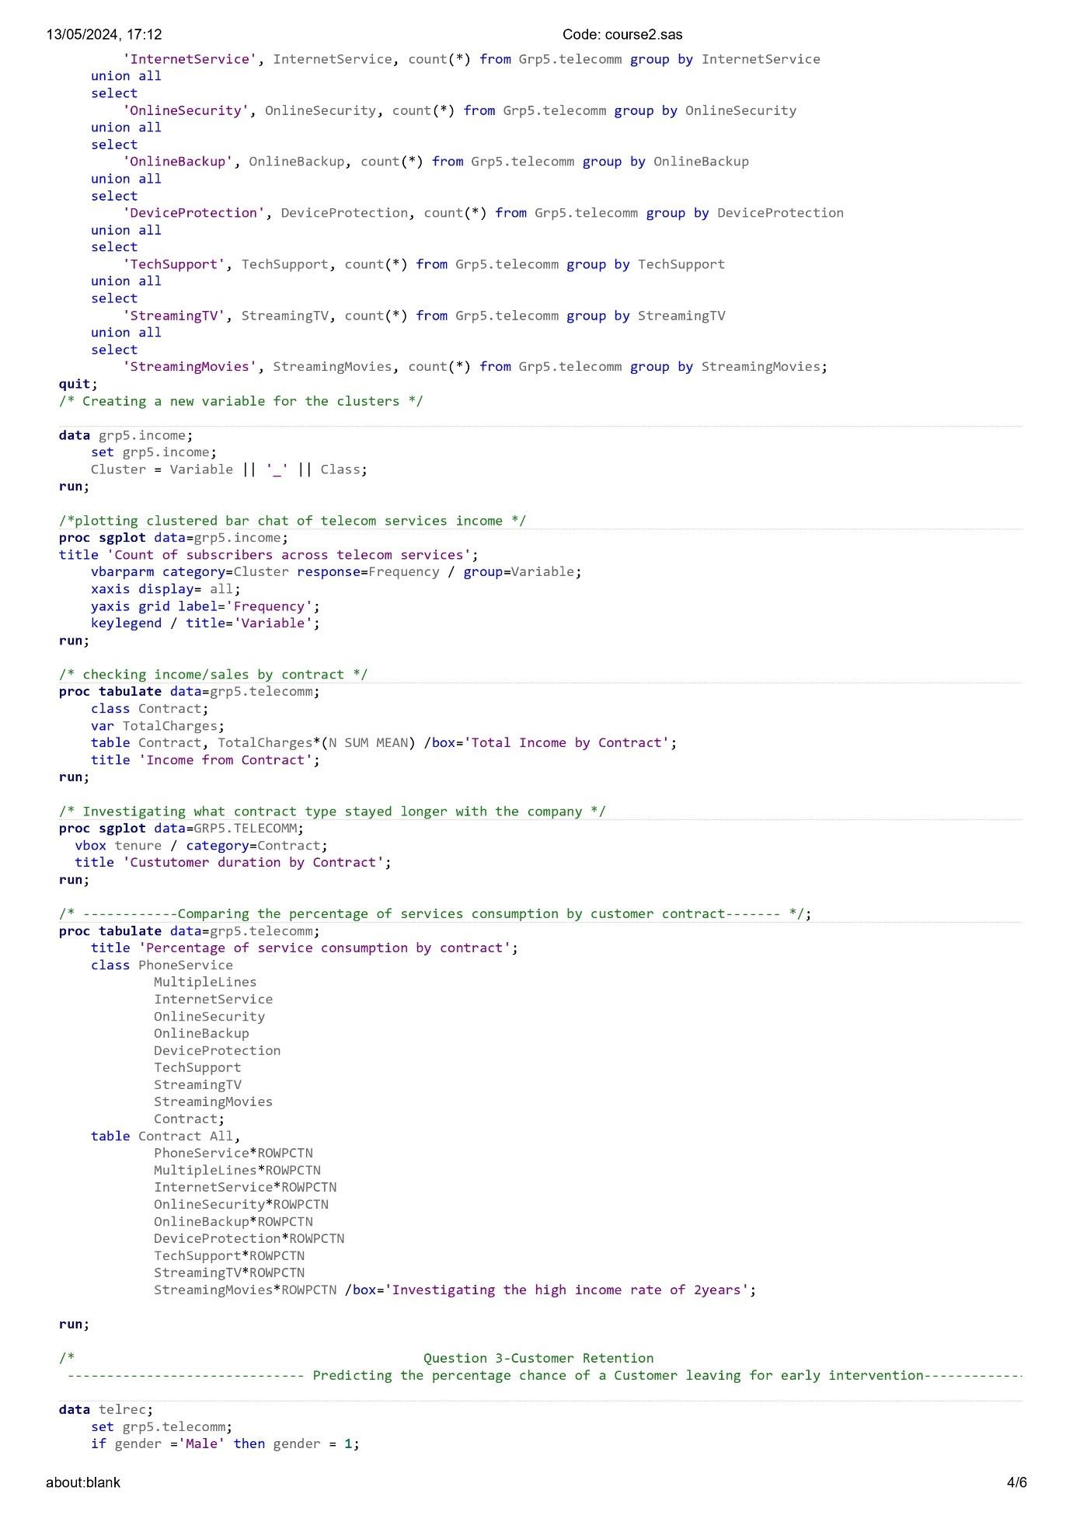

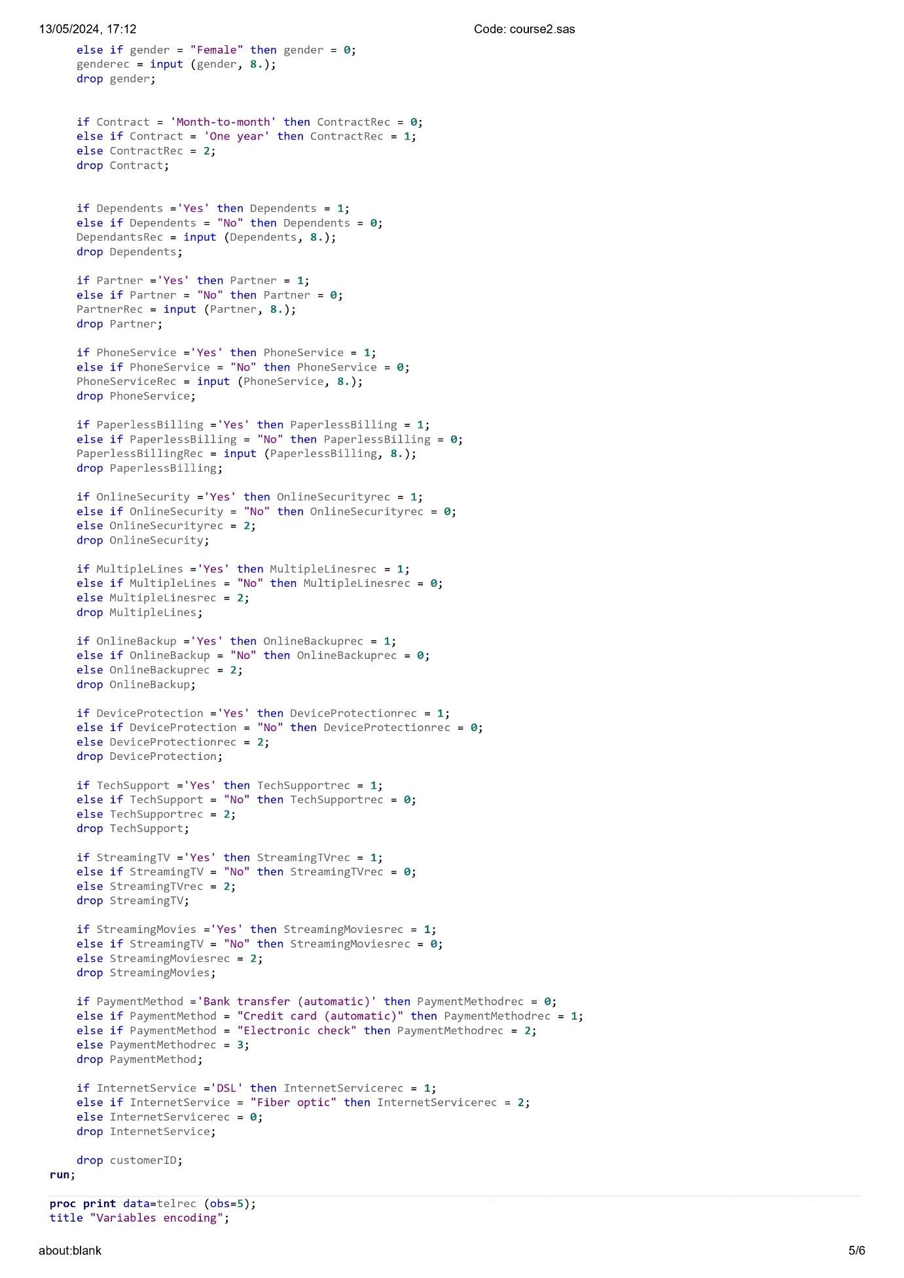

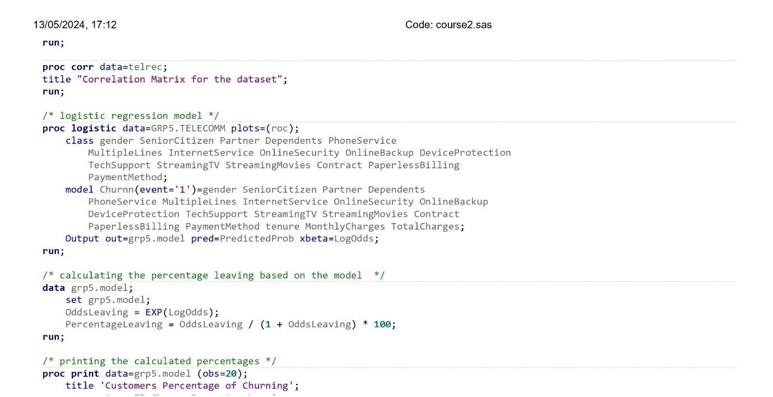

Appendix 2: SAS Output

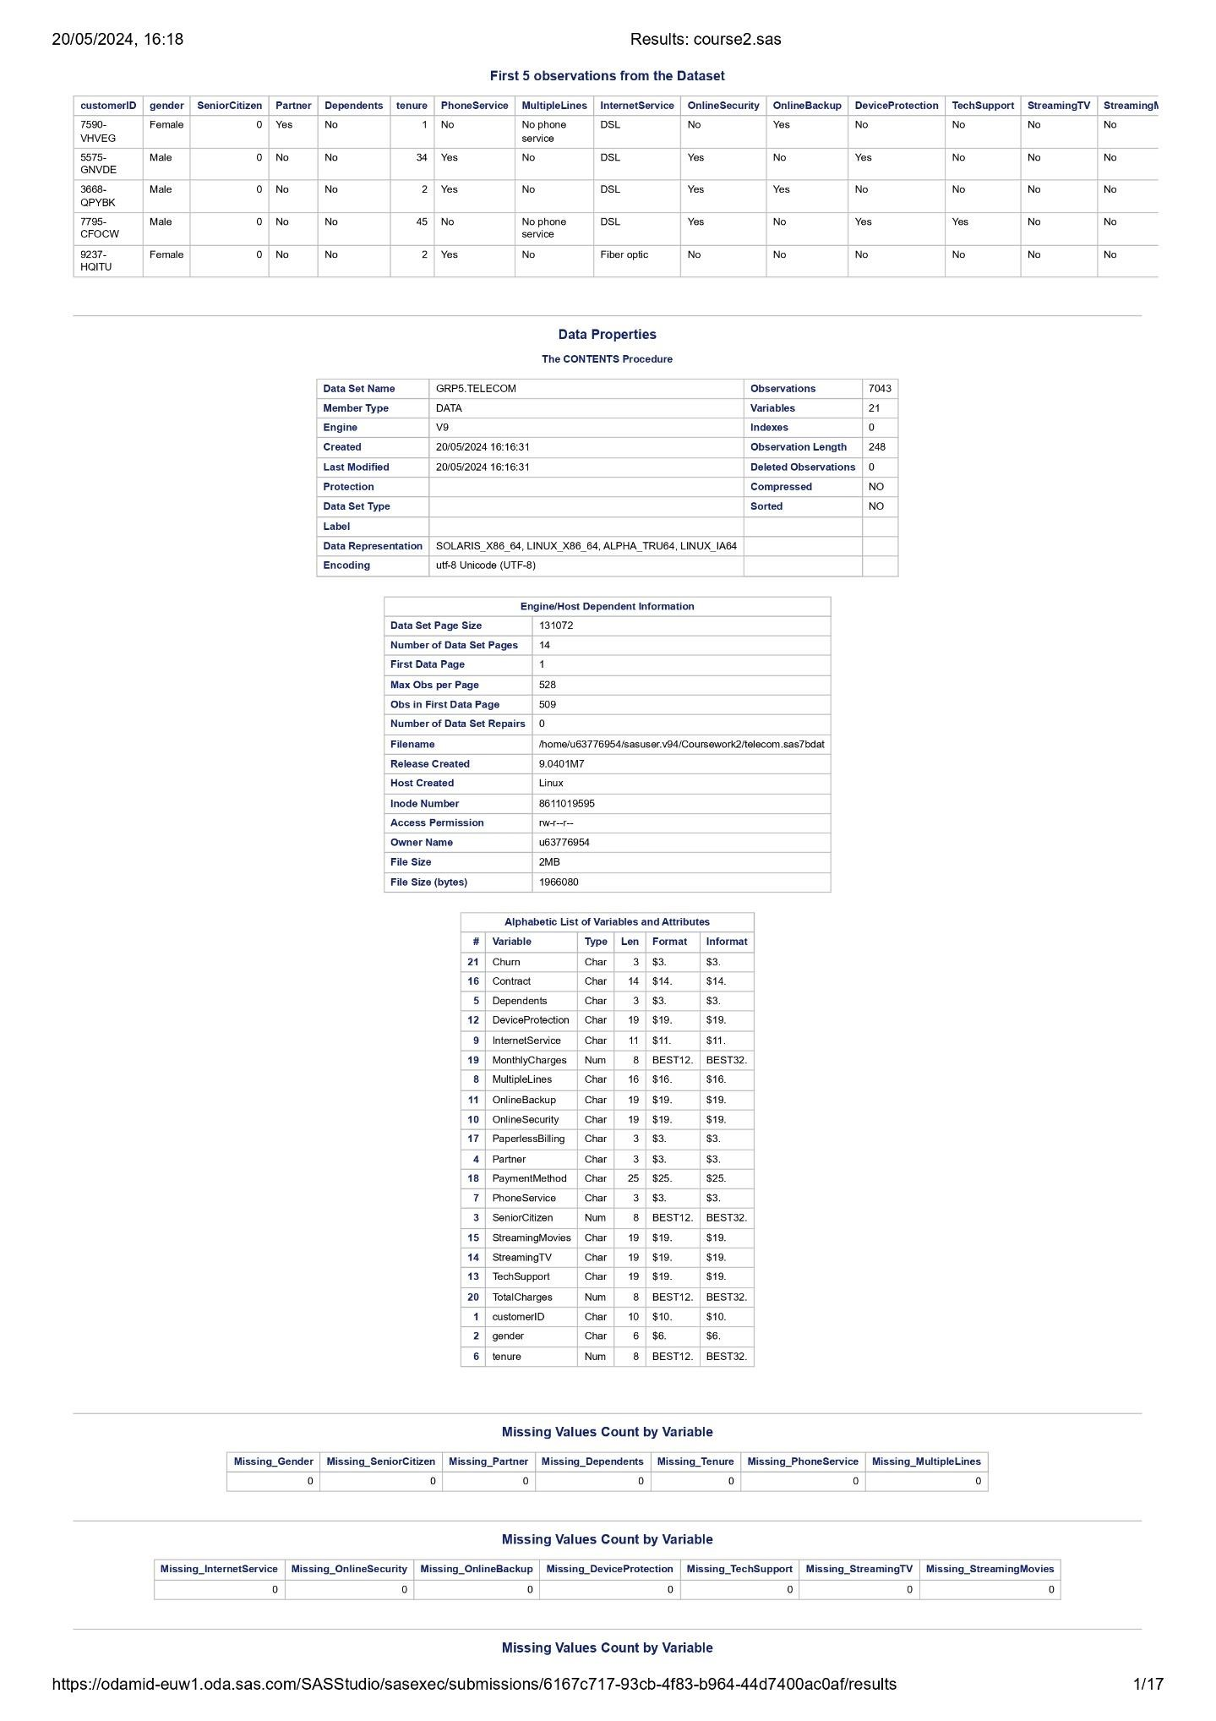

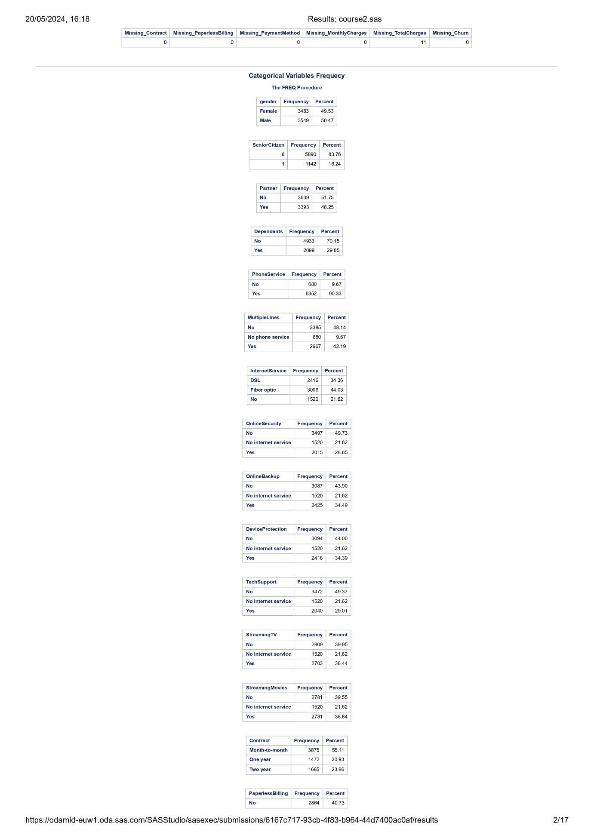

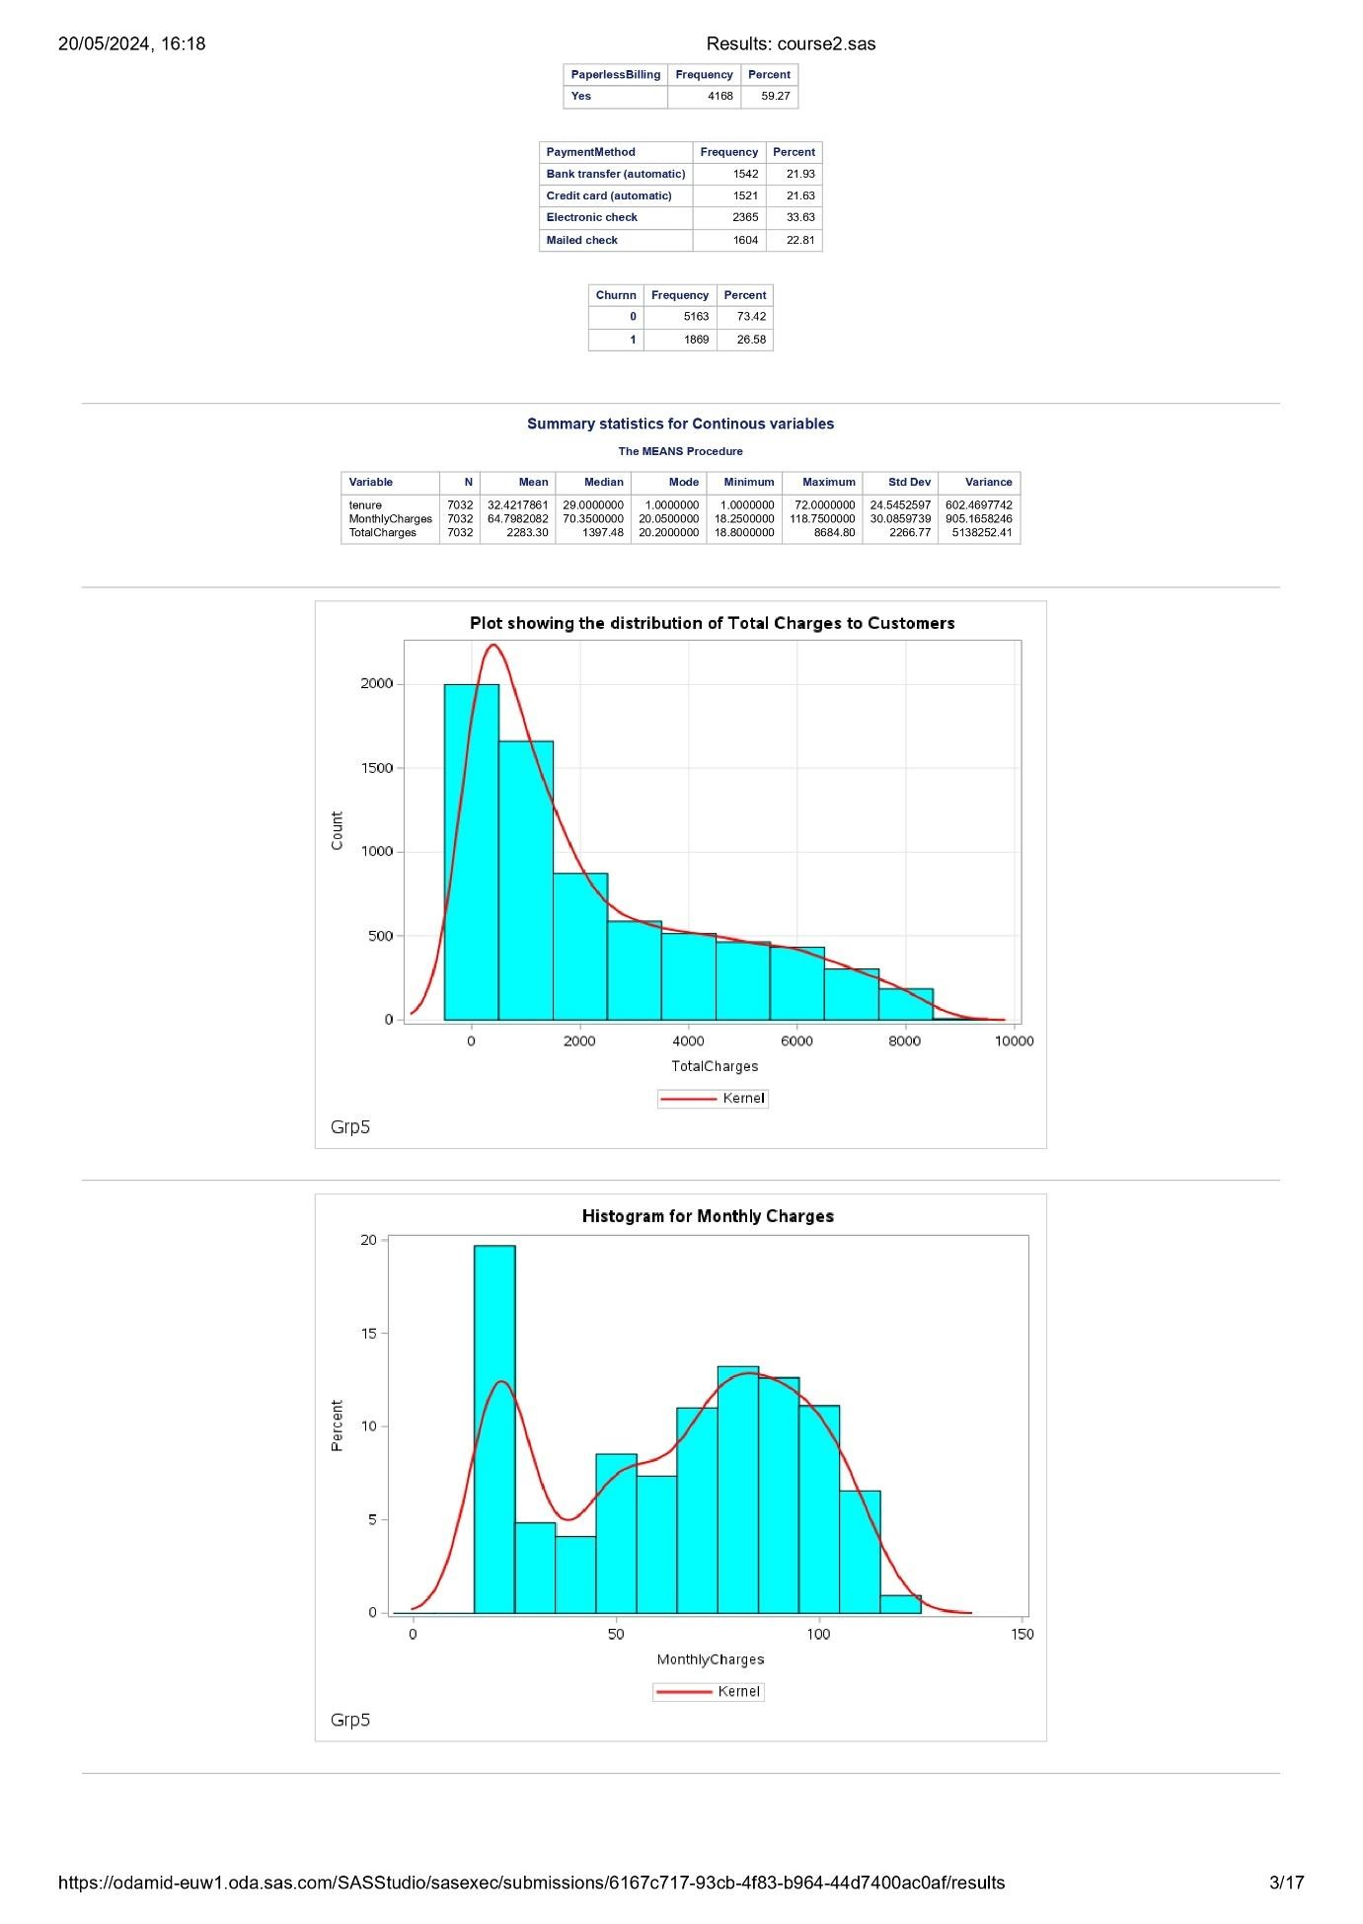

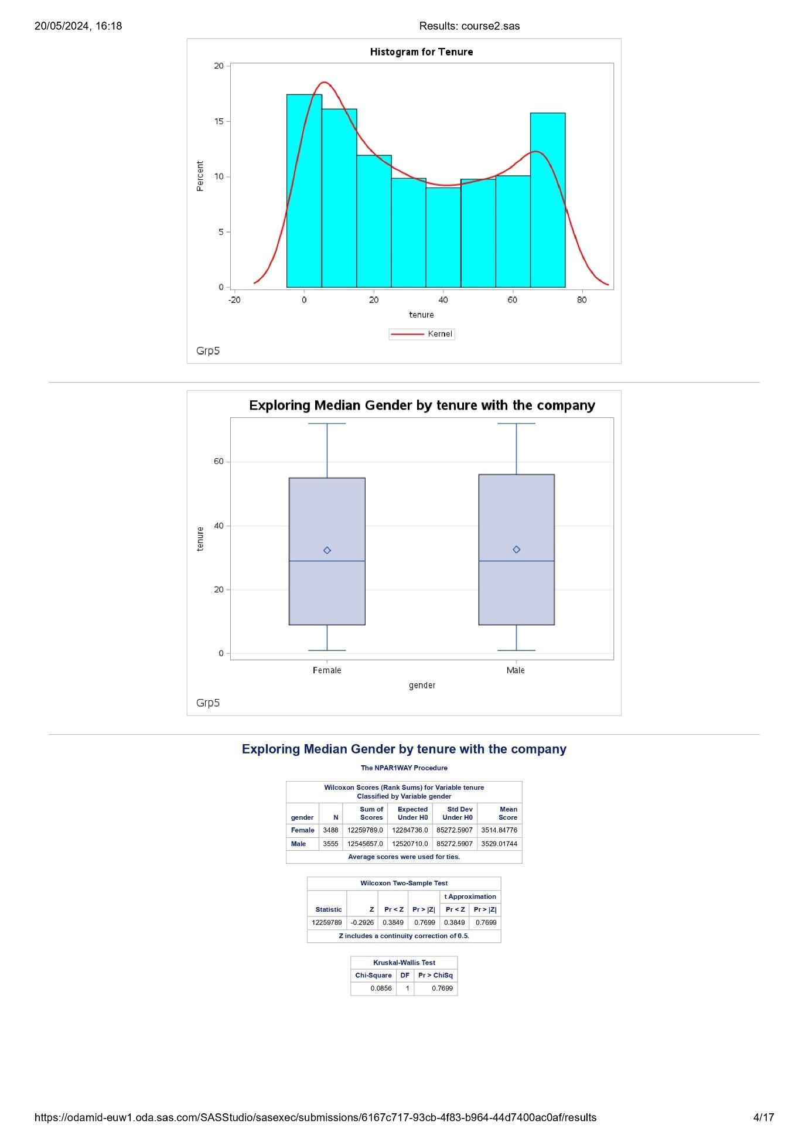

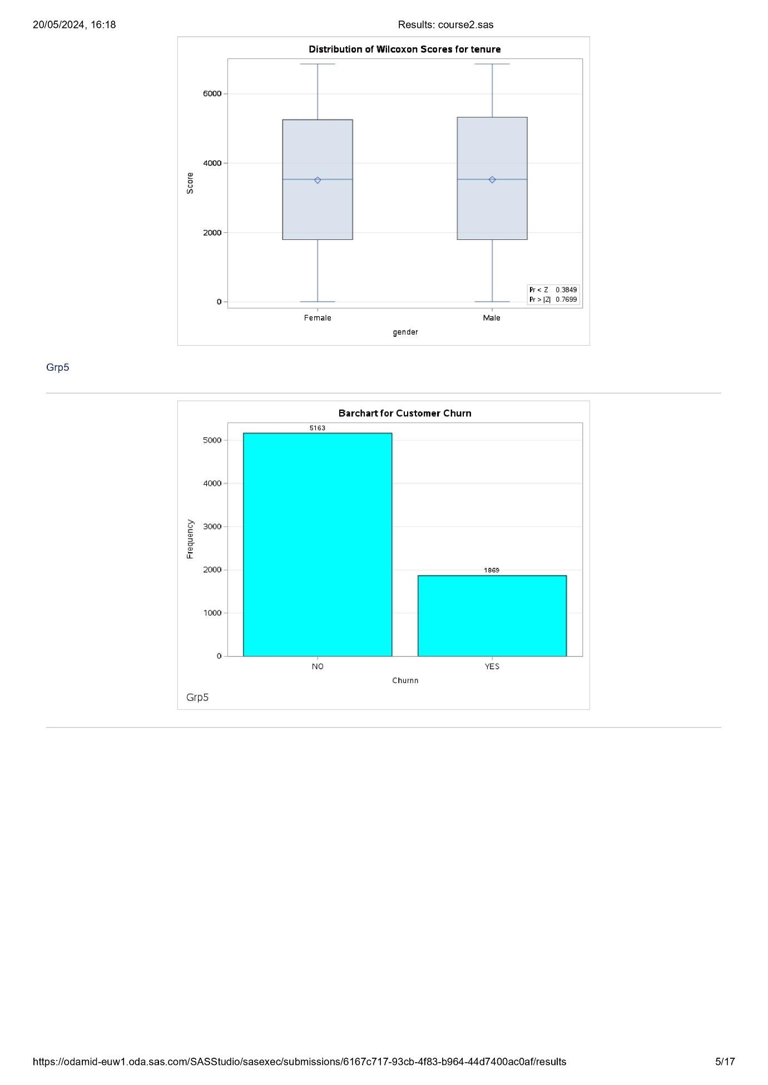

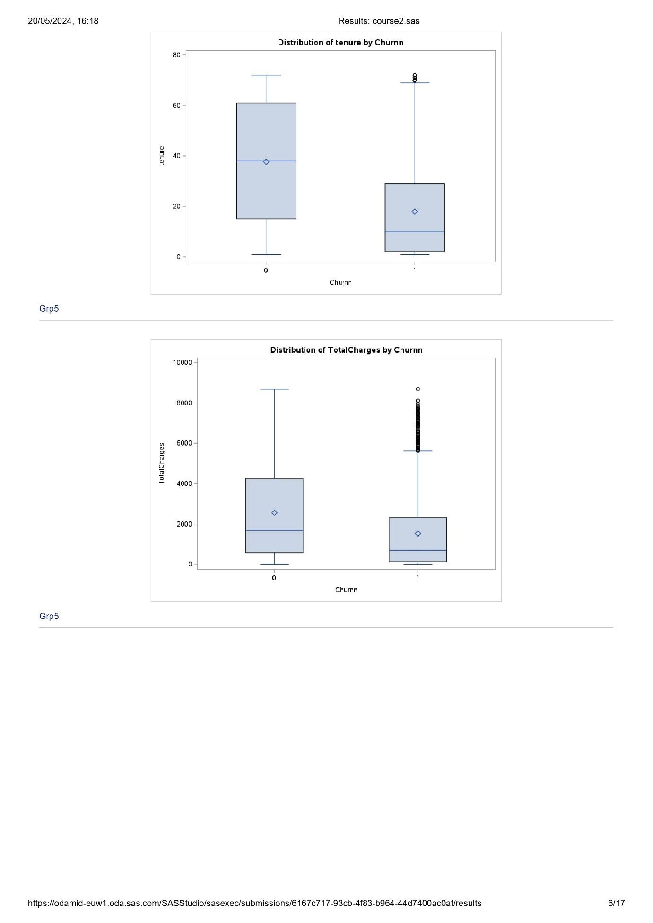

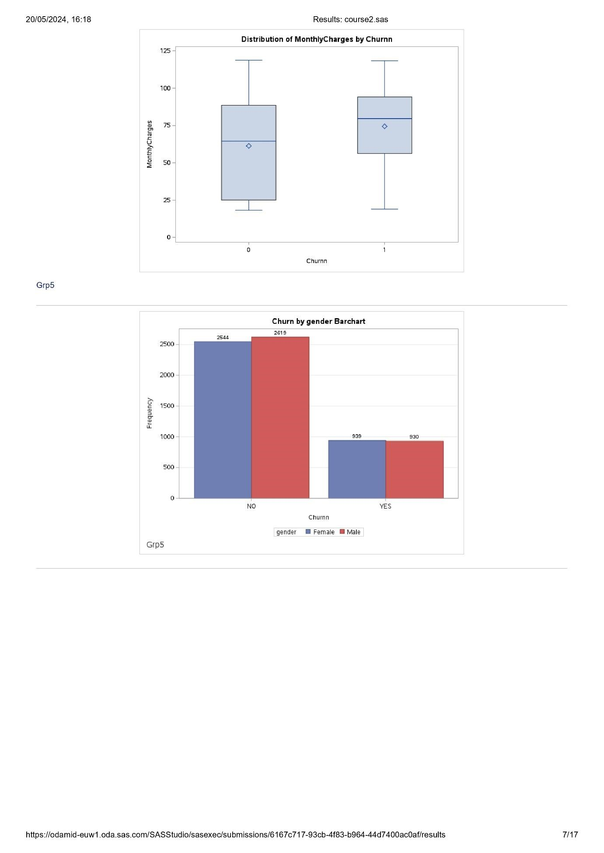

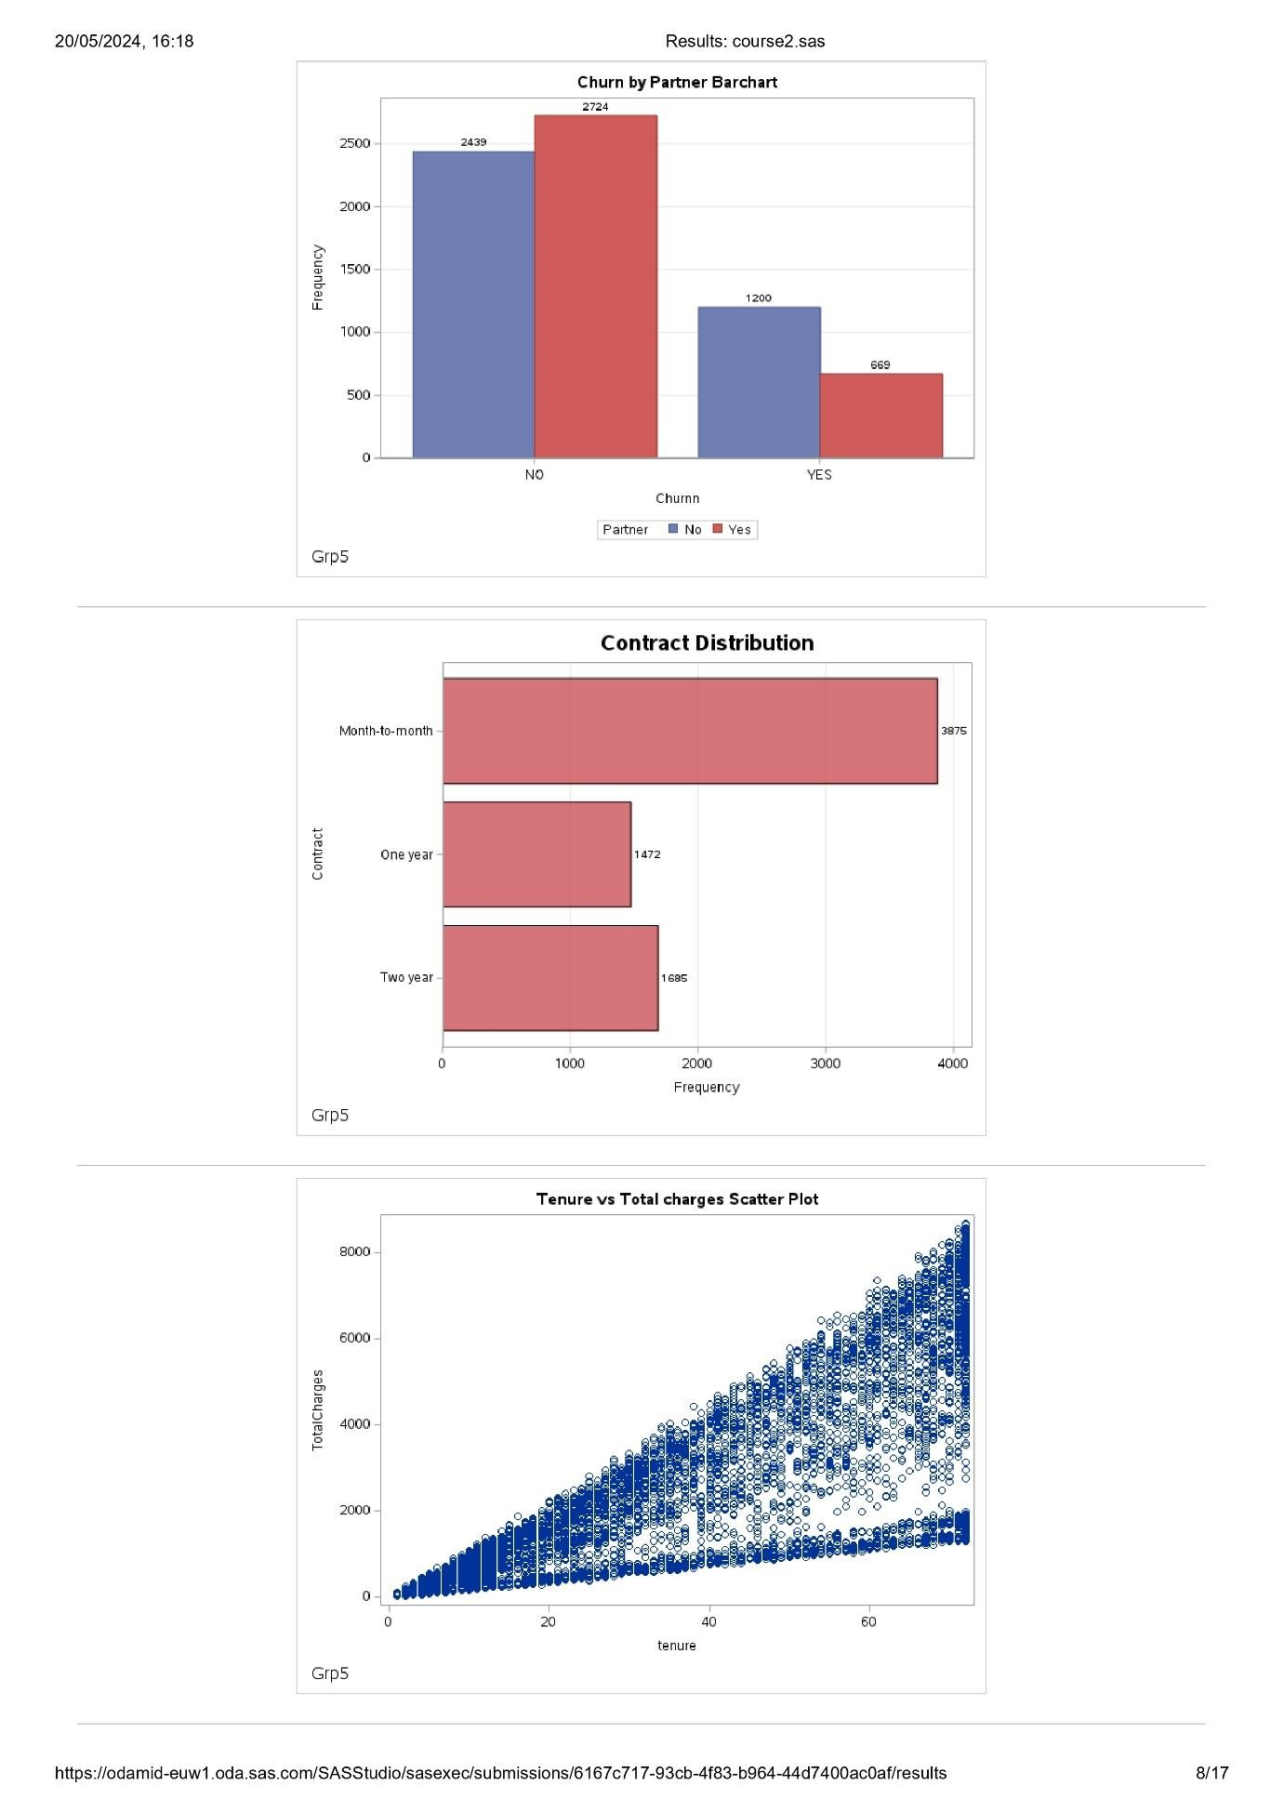

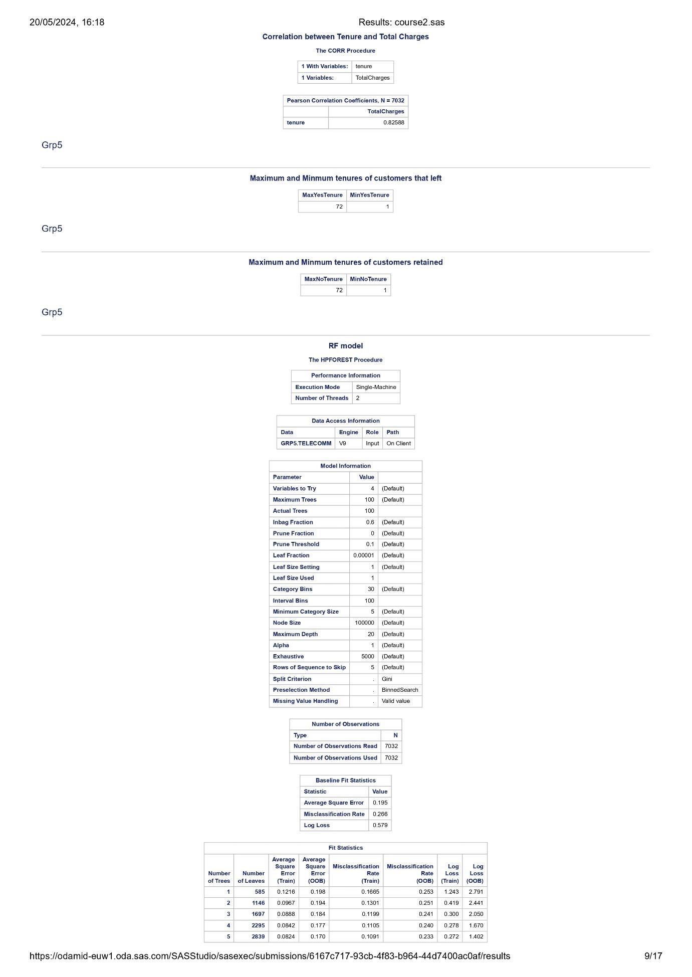

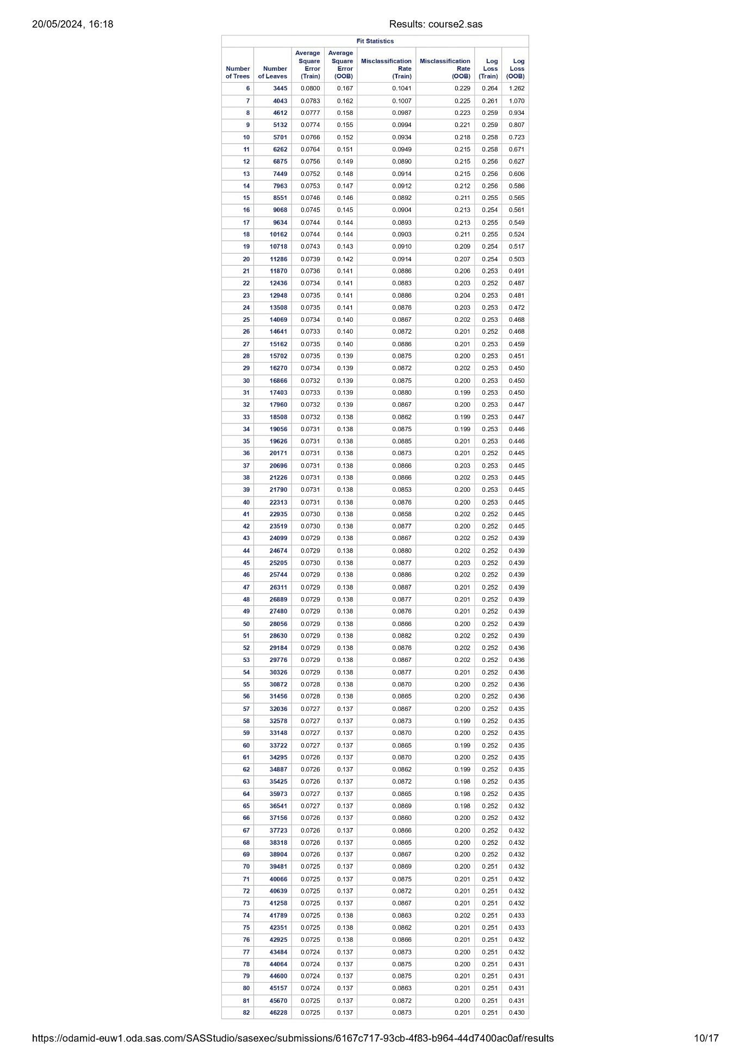

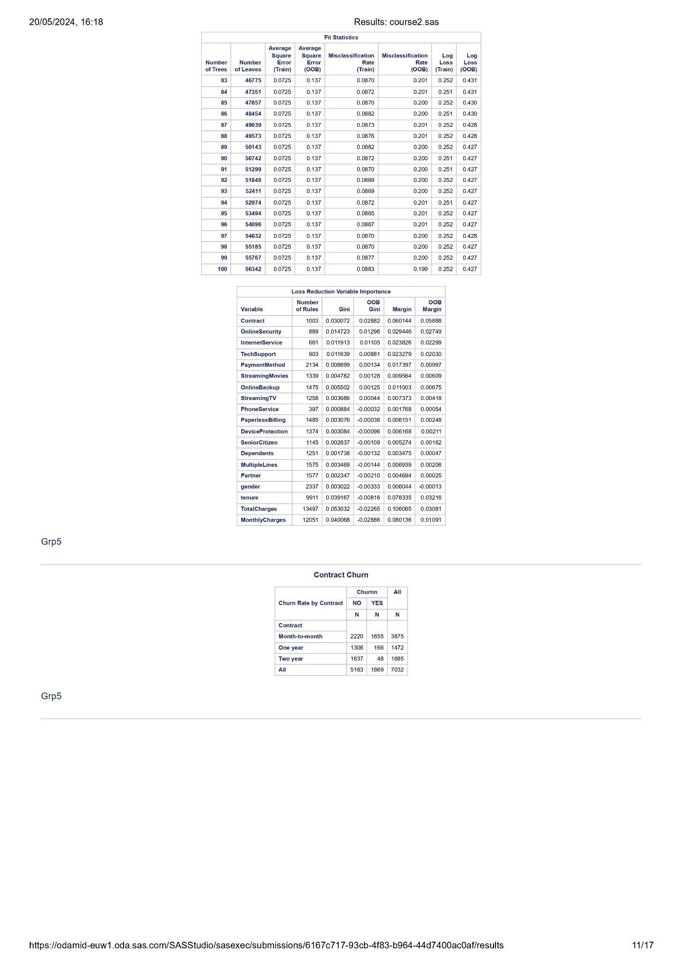

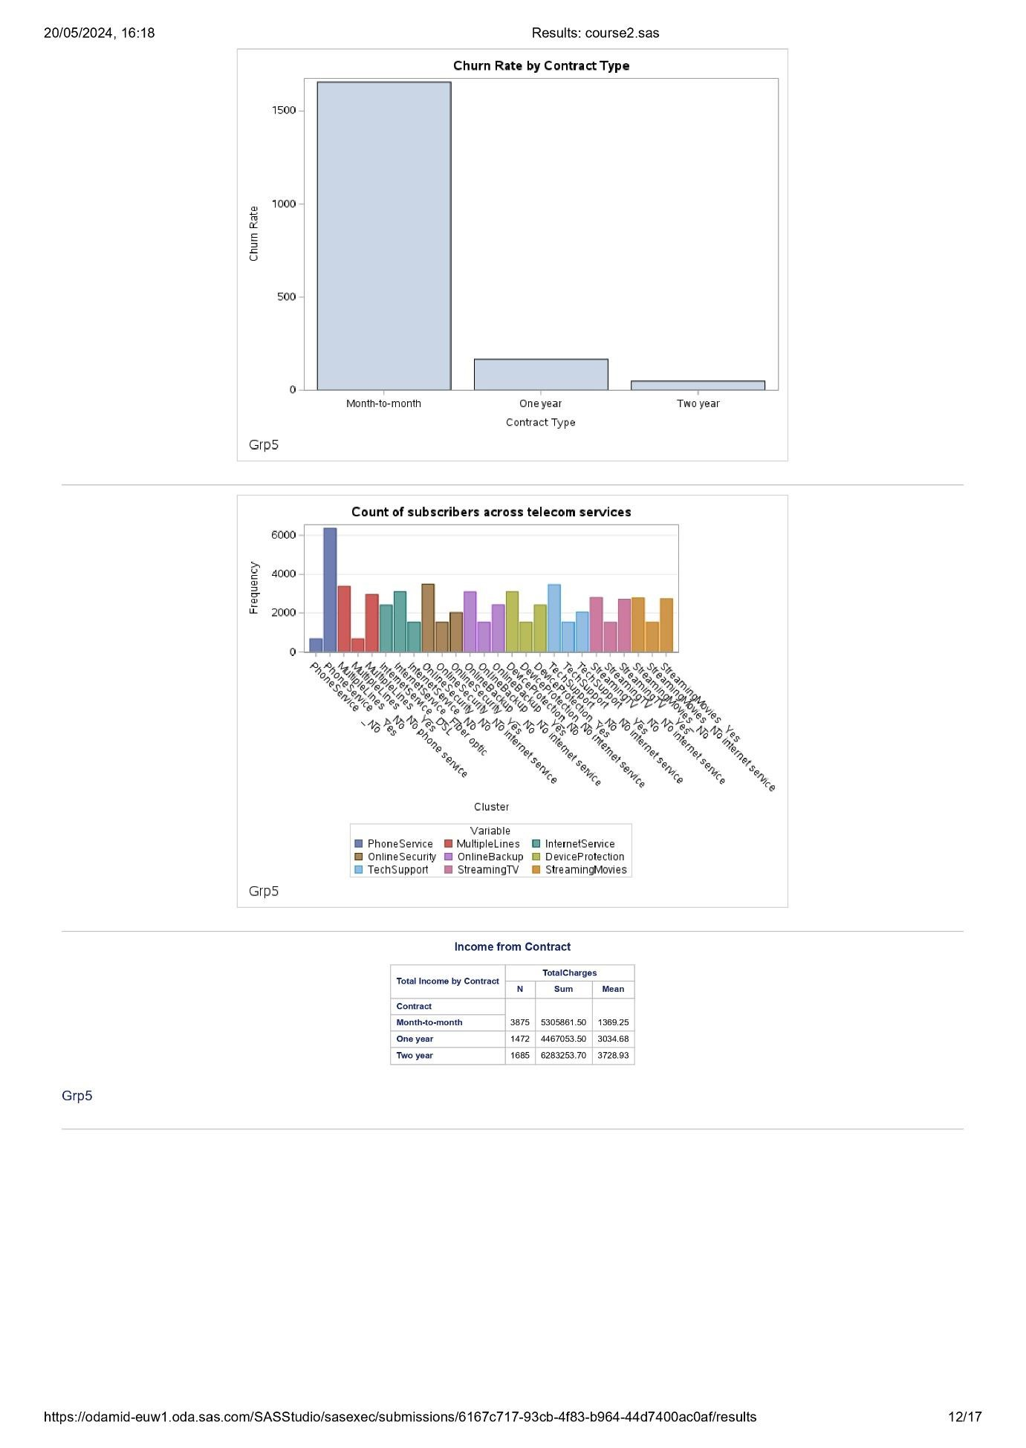

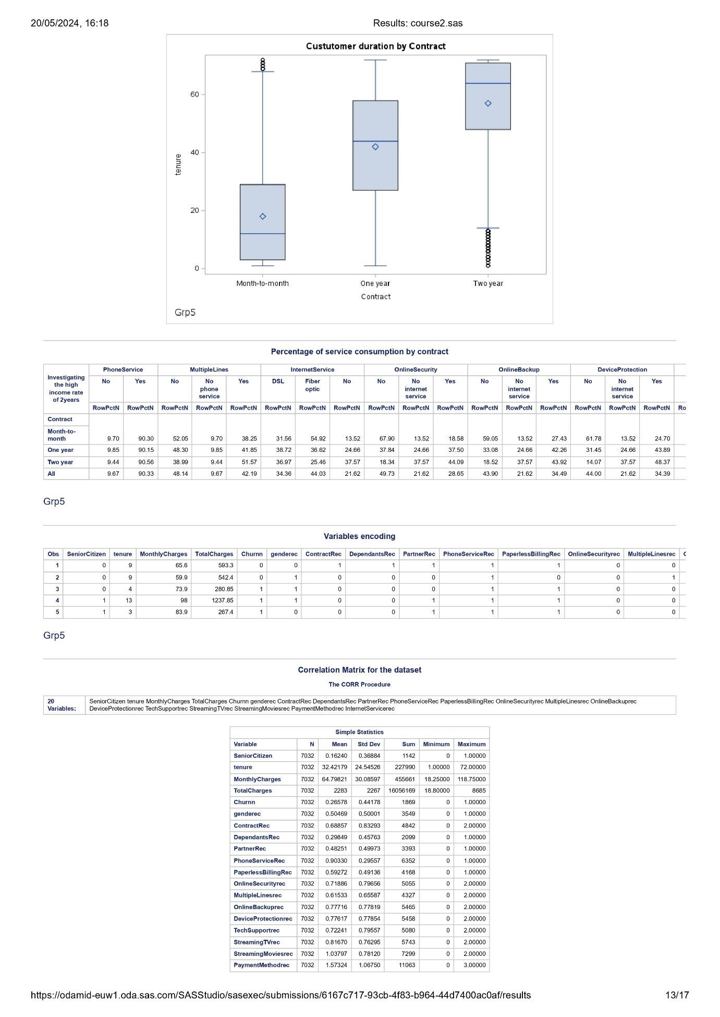

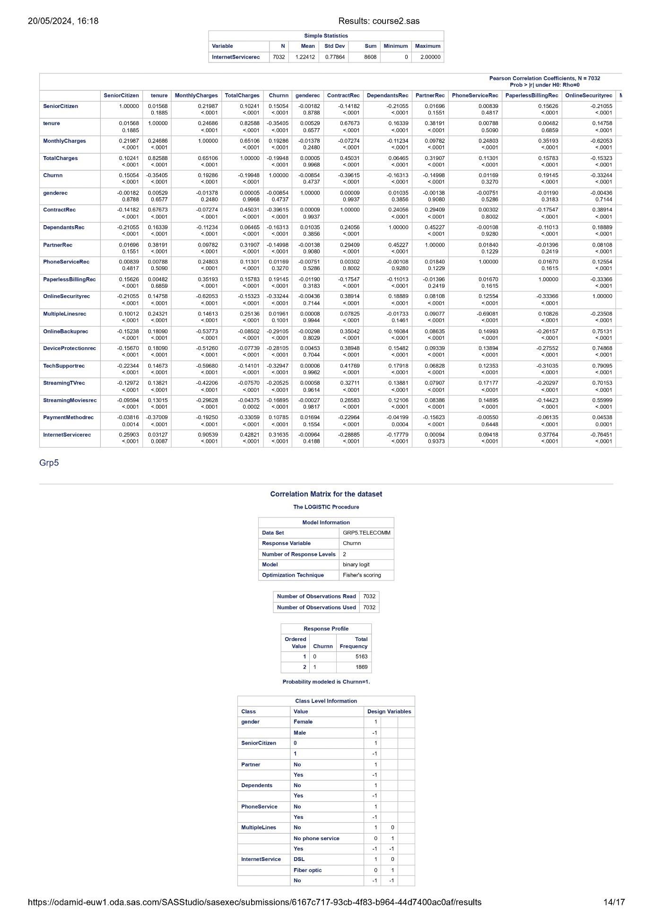

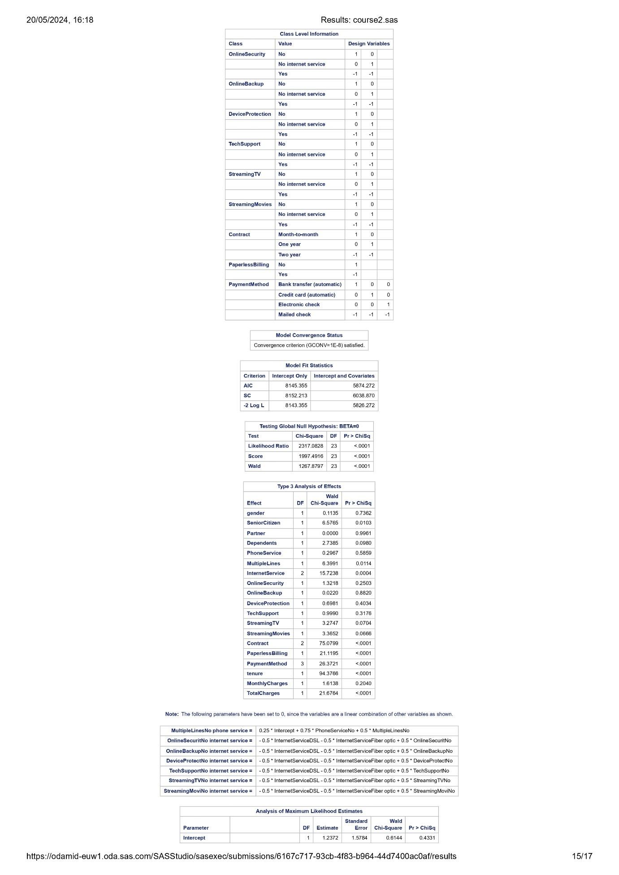

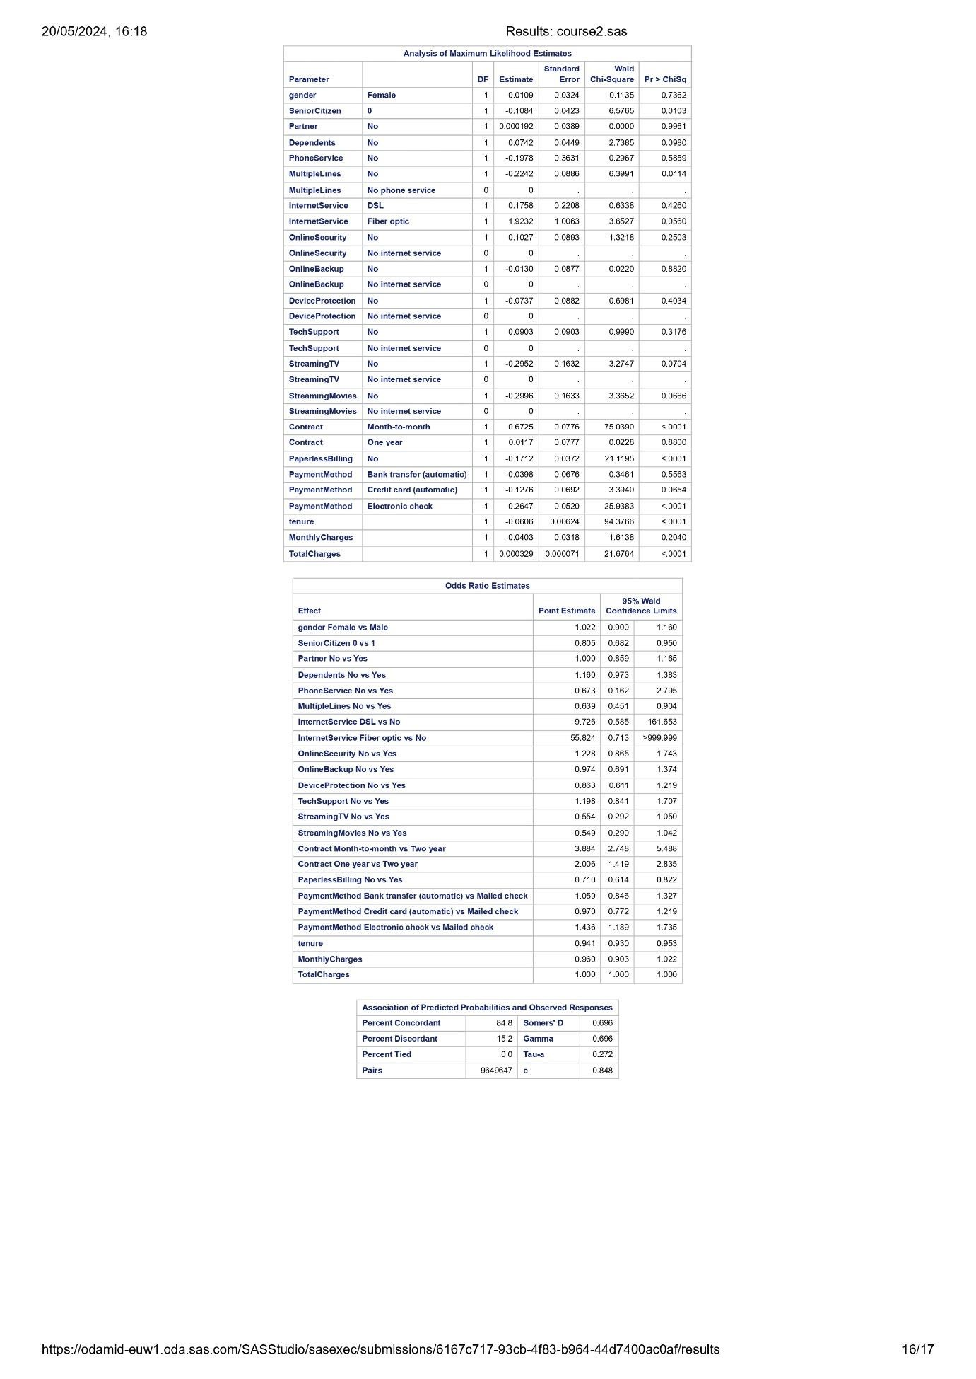

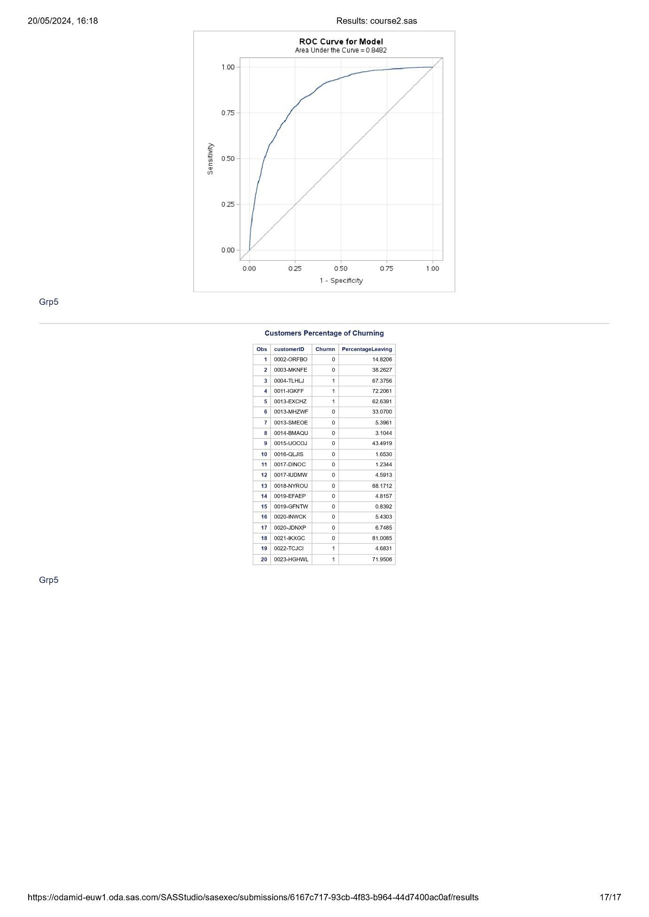

Appendix 3: Python Code and Output

